**教学管理系统**

**设计说明书**

班级 15软工A3

学号 20154831337

姓名 汪怡晖

**目 录**

**一、需求分析**

1. 目标用户 3

2. 主要功能 3

1. **概要设计**

1. 模块功能说明 3

1.1分配教学任务---------------------------------------------------------------------------------3

1.2选课注册---------------------------------------------------------------------------------------3

1.3成绩处理---------------------------------------------------------------------------------------3

1.4成绩统计分析---------------------------------------------------------------------------------4

1.5学生查询成绩---------------------------------------------------------------------------------4

1.6选择专业导师---------------------------------------------------------------------------------4

2.学生成绩管理数据流程图 4

**三、详细结构设计**

1. E-R图(CDM) 4

2. 表之间的关系(PDM) 5

3. 表空间 5

4. 用户 6

5. 视图 7

6. 存储过程 8

7. 函数 9

8. 触发器 9

**四、实现脚本**

0. 新增脚本 11

1. 表空间 12

2. 用户 13

3. 表与视图 15

4. 样本数据 22

5. 存储过程 26

6. 函数 31

7. 触发器 33

**五、调试分析和测试结果**

调试分析和测试结果 37

**一、需求分析**

1. **目标用户**

本系统的目标用户为学生用户、教师用户及管理部门用户。

1. **主要功能**

|  |  |
| --- | --- |
| 学生用户功能： | 1.查询个人档案信息  2.修改个人信息  3.查询考试成绩  4.在线选课  5.查询选课信息  6.修改登录密码  7.查询个人GPA  8.查询教师信息  9.选择一名老师作为专业导师 |
| 教师用户功能： | 1.录入学生成绩  2.查询学生成绩  3.修改学生成绩  4.查询教师个人信息  5.修改教师个人信息  6.修改课程信息  7.查看学生选课信息  8.查询辅导学生信息  9.修改辅导学生 |
| 管理部门用户功能： | 1.备份数据库  2.恢复数据库  3.倒库  4.为其他用户授权  5.修改教学计划  6.查询教师信息  7.统计学生考试成绩  8.修改账户  9.查看审计信息 |

1. **概要设计**
2. **模块功能说明**
   1. 分配教学任务
3. 由教学管理部门根据教学任务分配表录入教师的教学任务，
4. 也可根据实际进行修改；
5. 教师可查询本人的教学任务。
   1. 选课注册

每学期可选课程均来自教学任务信息。学生根据教学任务信息、课程基本信息以及学生基本信息，在规定的日期内，并在满足必选学分数等限制条件下完成选课，并将选课结果存入学生成绩数据表中；教师可从学生成绩数据表中提取选课学生名单，打印。

* 1. 成绩处理

教师批阅卷完毕后，由教师录入该科目的学生考试成绩，并打印提交成绩单。当选择授课教师、学年、学期、授课专业、授课班级后应自动出现课程名称，选择了课程名称后，系统应自动出现选择该课程的所有学生名单。如果因成绩遗漏或录入错误，教师可在得到管理部门的授权后，修改并重新录入成绩，永久保存。

* 1. 成绩统计分析

分别按班级、专业统计课程的优良率等。

* 1. 学生查询成绩

学生通过校园网或互联网查询本人的课程成绩。

* 1. 选择专业导师

学生通过查询教师信息选择一名专业导师。老师可修改所辅导学生。

1. **学生成绩管理数据流程图**



**三、详细设计**

1. **E-R图(CDM)**



1. **表之间的关系(PDM)**



1. **表空间**

**3.1 表空间分配**

教学管理数据库EnterDB.dlpu.dalian存储有7个表，总存储量约有280MB。

（1）数据文件、重做日志文件以及控制文件以及相关的参数文件等原则上应尽可能分别存放，不能存储在同一个磁盘或分区上。

（2）因成绩查询比较频繁，应将数据与索引分别存储在数据表空间和索引表空间。

（3）主要数据存储在一个表空间里。

|  |  |  |  |  |  |
| --- | --- | --- | --- | --- | --- |
| **表名** | **所属模式** | **对应所属部门** | **对应表空间** | **初始大小** | **增长方式** |
| DB_COLLEGE  DB_MAJOR  DB_STUDENT  DB_TEACHER  DB_COURSE  DB_TEACH_COURSE  DB_MAJOR_TEACH | Staffuser  Staffuser  Staffuser  Staffuser  Staffuser  Staffuser  Staffuser | 全校各学院  各学院专业  全校学生  全校教师  全校所有课程  所有专业  所有专业导师与辅导学生 | tbs_main  tbs_main  tbs_main  tbs_main  tbs_main  tbs_main  tbs_main | 500M  500M  500M  500M  500M  500M  500M | 自动  自动  自动  自动  自动  自动  自动 |
| DB_GRADE | Staffuser | 生物工程学院  食品科学与工程学院 | tbs_bio_foo | 200M | 自动 |
| 信息科学与工程学院  材料科学与工程学院 | tbs_infor_mati | 200M | 自动 |
| 艺术设计学院  服装学院  商务学院 | tbs_art_fash_busi | 200M | 自动 |

**3.2 表空间与文件**

|  |  |  |  |  |  |
| --- | --- | --- | --- | --- | --- |
| **表空间** | **类型** | **对应文件** | **文件大小(MB)** | **增长幅度(%)** | **增长方式** |
| tbs_main | 永久/联机 | tbs_main1.ora  tbs_main2.ora | 250  250 | 10  10 | 自动  自动 |
| tbs_bio_foo | 永久/联机 | tbs_bio_foo1.ora  tbs_bio_foo2.ora | 100  100 | 10  10 | 自动  自动 |
| tbs_infor_mati | 永久/联机 | tbs_infor_mati1.ora  tbs_infor_mati2.ora | 100  100 | 10  10 | 自动  自动 |
| tbs_art_fash_busi | 永久/联机 | tbs_art_fash_busi1.ora  tbs_art_fash_busi2.ora | 100  100 | 10  10 | 自动  自动 |
| tbs_teach_std | 永久/联机 | tbs_teach_std1.ora  tbs_teach_std2.ora | 100  100 | 10  10 | 自动  自动 |
| tbs_index | 永久/联机 | tbs_index1.ora  tbs_index2.ora | 100  100 | 10  10 | 自动  自动 |
| tbs_temp | 临时/联机 | tbs_temp1.ora  tbs_temp2.ora | 100  100 | 10  10 | 自动  自动 |

1. **用户**

**4.1 表空间与用户及表的对应关系**

教学管理数据库EnterDB.dlpu.dalian有五个数据库用户

|  |  |  |  |
| --- | --- | --- | --- |
| **数据库用户** | **拥有的表** | **表的默认表空间** | **程序对象** |
| staffuser | DB_COLLEGE  DB_MAJOR  DB_STUDENT  DB_TEACHER  DB_TEACH_COURSE  DB_COURSE  DB_MAJOR_TEACH | tbs_main | 触发器、存储过程、存储函数、包及数据库链接等 |
| DB_GRADE(分区表) | tbs_bio_foo |  |
| tbs_infor_mati |
| tbs_art_fash_busi |
| dbdatauser  dbsysuser |  | tbs_main |  |
| teauser | DB_FACULTY_PER | tbs_teach_std | 部分应用程序对象 |
| stduser | DB_STUDENT_PER |

**4.2 用户与表之间权限**

|  |  |  |  |  |  |
| --- | --- | --- | --- | --- | --- |
| **数据库用户**  **表数据** | **teauser** | **stduser** | **staffuser** | **dbdatauser** | **dbsysuser** |
| db_college | S |  | SIUD | S | SX |
| db_major | S |  | SIUD | S | SX |
| db_Student |  | SU | SIUD | S | SX |
| db_teacher | SU |  | SIUD | S | SX |
| db_course | S | S | SIUD | S | SX |
| db_grade | SU | SU |  | S | SX |
| db_teach_course | S | S | SIUD | S | SX |
| db_faculty_permi | SU |  | SIUD | S | SX |
| db_student_permi |  | SU | SIUD | S | SX |
| db_major_teacher | SU | SU | SIUD | S | SX |

**4.3 用户口令、权限及角色初步分配**

|  |  |  |  |
| --- | --- | --- | --- |
| **用户名** | **口令** | **授予的角色** | **授予的系统权限** |
| staffuser | staffuser | CONNECT; RESOURCE | Create function; Create view;  Create package;  Drop table; Alter table |
| teauser | teauser | CONNECT; RESOURCE | Create view;  Create synonym |
| stduser | stduser | CONNECT; RESOURCE | Create view;  Create synonym |
| dbdatauser | dbdatauser | DATAPUMP_EXP_FULL_DATABASE;  DATAPUMP_IMP_FULL_DATABASE;  EXP_FULL_DATABASE;  IMP_FULL_DATABASE; RESOURCE | EXPORT FULL DATABASE  IMPORT FULL DATABAS |
| dbsysuser | dbsysuser | DBA |  |

1. **视图**

有两类用户：教师和学生

**5.1 teauser查询并可更改的信息**

教师用户teauser查询并可更改staffuser模式下的部分信息

|  |  |  |  |
| --- | --- | --- | --- |
| **定义视图名称** | **查询的列** | **可更改的列** | **相关表** |
| vt_teach_colleg | work_id，t_name，t_titles，major_name，college_name，t_address，t_telephone，t_position，t_email |  | db_teacher  db_major  db_college |
| vt_teach_upd |  | t_address，t_email,  t_telephone，t_position | db_teacher |
| vt_ teach_cs | course_no，work_id，course_name，launch_year，launch_term，executed_plan |  | db_teach_course |
| vt_teach_grade | register_no，course_name，t_name，credit,registered_date，registered_year，final_Grade，  registered_term，makeup_flag |  | db_grade  db_teacher  db_Student |
| vt_grade_upd |  | s_mail_address，  s_postcode，  s_address，s_tele，  s_email | db_grade |

**5.2 stduser查询并可更改的信息**

学生用户stduser能查询自己的信息、课程及选课成绩及教师承担的教学任务等；允许修改自己的部分信息**。**

|  |  |  |  |
| --- | --- | --- | --- |
| **定义视图名称** | **查询的列** | **可更改的列** | **相关表** |
| vs_grade_teach | register_no，course_name，  registered_date，registered_year,credit，  registered_term,t_name,final_grade,makeup_flag |  | db_grade  db_teacher |
| vs_grade_upd |  | course_name，registered_date，  work_id,registered_term,registered_year | db_grade |
| vs_student | register_no，s_name，s_gender,s_class,s_tele,s_dateofbirth, s_address，s_postcode,s_email,s_mail_address |  | db_Student |
| vs_student_upd |  | s_mail_address，s_postcode，  s_address，s_tele，s_email | db_Student |

1. **存储过程**

**6.1 与stduser相关的部分存储过程**

|  |  |  |  |
| --- | --- | --- | --- |
| **定义存储过程名** | **功能** | **相关表及列** | **所属用户** |
| p_query_std_in | 查询学生个人信息 | 相关表：db_student  查询：register_no  输出：s_address,s_postcode,  s_mail_address,s_tele,s_email | staffuser |
| p_upd_std_inf | 修改学生个人信息 | 相关表：db_student  查询：register_no  更新：s_address,s_postcode,  s_mail_address,s_tele,s_email | staffuser |
| p_query_std_grade | 查询考试成绩 | 相关表：db_grade  查询：register_no和course_name | staffuser |
| p_ins_upd_course | 在线选课 | 相关表：db_student，db_teacher，db_teach_course，db_grade | staffuser |
| p_cancel_reg_course | 注销已选课 | 相关表：db_student，db_major，db_teach_course，db_grade | staffuser |
| p_upd_std_pwd | 修改登录口令 | 相关表：db_student_per  查询：register_no，login_pwd_s  更新：login_pwd_ | stduser |
| p_std_tot_gpa | 查询GPA | 相关表：db_grade  查询：register_no | staffuser |
| p_ins_maj_tea | 选择专业导师 | 相关表：db_student，db_teacher，db_major_teacher | staffuser |

**6.2 与teauser相关的部分存储过程**

|  |  |  |  |
| --- | --- | --- | --- |
| **定义存储过程名** | **功能** | **相关表及列** | **所属用户** |
| p_query_tea_grade | 查询学生成绩 | 相关表：db_student，db_major，db_teacher，db_grade  查询：register_no,work_id,  course_name | staffuser |
| p_insert_tea_grade | 录入学生成绩 | 相关表：db_grade | staffuser |
| p_upd_tea_grade | 修改学生成绩 | 相关表：db_grade | staffuser |
| p_upd_tea_pwd | 修改口令 | 相关表：db_faculty_per  查询：work_id，login_pwd_f  更新：login_pwd_f | teauser |
| p_upd_staf_course | 修改教学计划 | 相关表：db_teach_course，db_course  查询：work_id，course_no  更新：course_no，course_name | staffuser |
| p_dele_maj_std | 删除辅导学生 | 相关表：db_major_teacher | staffuser |

1. **函数**

**7.1 所需函数及功能**

|  |  |  |  |
| --- | --- | --- | --- |
| **定义函数名** | **功能** | **相关表及列** | **所属用户** |
| fun_query_std_gra | 查询单科考试成绩 | 相关表：db_grade  查询：register_no和course_name | staffuser |
| fun_std_avg_gra | 按学期查询学生平均成绩 | 相关表：db_grade  查询：register_no和course_name | staffuser |
| fun_std_total_avg_gra | 查询学生所有课程平均成绩 | 相关表：db_grade  查询：register_no和course_name | staffuser |
| fun_std_tot_gpa | 查询某学生的GPA | 相关表：db_grade  查询：register_no | staffuser |
| fun_std_term_avg_gra | 按专业、学期查询学生平均成绩 | 相关表：db_grade  查询：register_no，registered_term | staffuser |

1. **触发器**

**8.1 与用户staffuser相关的部分触发器**

|  |  |  |
| --- | --- | --- |
| **定义触发器名** | **功能** | **所属用户** |
| tri_startup _db | 记录启动数据库的时间、用户等 | sys |
| tri_shutdown_db | 记录关闭数据库的时间、用户等 | sys |
| tri _login_user | 自动记录登录系统的用户信息，包括登录的IP, 主机名，登录时间，用户名等 | sys |
| tri _logout_user | 记载注销系统的用户信息，包括注销的IP、主机名、注销时间、用户名等 | sys |
| tri_restrict_upd_time | 在周六、周日上午8点至下午5点，不能对数据库db_grade表进行更新修改 | staffuser |
| tri_dele_faculty_his | 自动记录离职教师的信息 | staffuser |
| tri _logon_scheme | 登录某用户时系统自动记录用户信息 | staffuser |
| tri _logoff_scheme | 用户注销时自动记录用户注销的时间，用户名等 | staffuser |
| tri_aud_sche_operation | 记录用户的DDL操作 | staffuser |

1. **实现脚本**

**新增脚本：**

**创建专业导师表：db_major_teacher**

CREATE TABLE db_major_teacher(

WORK_ID CHAR(6) NOT NULL,

REGISTER_NO CHAR(12) NOT NULL,

CONSTRAINT PK_RNO_WID PRIMARY KEY(REGISTER_NO,WORK_ID) VALIDATE,

CONSTRAINT FK_MT_REGISTER_NO FOREIGN KEY(REGISTER_NO) REFERENCES DB_STUDENT(REGISTER_NO) VALIDATE,

CONSTRAINT FK_MT_WID FOREIGN KEY(WORK_ID) REFERENCES DB_TEACHER(WORK_ID) VALIDATE)

ORGANIZATION INDEX TABLESPACE TBS_MAIN

PCTFREE 10

INITRANS 50

MAXTRANS 4

STORAGE (BUFFER_POOL KEEP)

LOGGING NOCOMPRESS

PARALLEL

/

**存储过程：**

**学生选择专业导师：p_ins_maj_tea**

CREATE OR REPLACE PROCEDURE p_ins_maj_tea

(v_work_id db_major_teacher.work_id%type,

v_reg_no db_major_teacher.Register_no%type

)

AS

BEGIN

INSERT INTO db_major_teacher(work_id,register_no)

VALUES(v_work_id,v_reg_no);

END p_ins_maj_tea;

/

**教师删除辅导学生：p_dele_maj_std**

CREATE OR REPLACE PROCEDURE p_dele_maj_std(

v_work_id IN db_major_teacher.work_id%type,

v_reg_no IN db_major_teacher.register_no%type

)

AS

BEGIN

DELETE db_major_teacher

WHERE register_no=v_reg_no AND work_id=v_work_id;

IF SQL%NOTFOUND THEN

DBMS_OUTPUT.PUT_LINE('该学生不存在！');

END IF;

COMMIT;

END p_dele_maj_std;

/

**查询学生GPA：p_std_tot_gpa**

CREATE OR REPLACE PROCEDURE p_std_tot_gpa(

v_reg_no IN db_grade.register_no%type,

v_gpa OUT number

)

AS

BEGIN

v_gpa:=round(fun_std_tot_gpa(v_reg_no),2);

END p_std_tot_gpa;

/

**1_创建表空间**

**1_tbs_main.sql**

CREATE SMALLFILE TABLESPACE Tbs_main

DATAFILE

'C:\app\james_000\oradata\EnterDB\Tbs_main1.ora' SIZE 250M

AUTOEXTEND ON

NEXT 25M

MAXSIZE UNLIMITED,

'C:\app\james_000\oradata\EnterDB\Tbs_main2.ora' SIZE 250M

AUTOEXTEND ON

NEXT 25K

MAXSIZE UNLIMITED

LOGGING

EXTENT MANAGEMENT LOCAL

SEGMENT SPACE MANAGEMENT AUTO

/

**2_tbs_bio_foo.sql**

CREATE SMALLFILE TABLESPACE Tbs_bio_foo DATAFILE

'C:\app\james_000\oradata\EnterDB\Tbs_bio_foo1.ora' SIZE 100M

AUTOEXTEND ON

NEXT 10M

MAXSIZE UNLIMITED,

'C:\app\james_000\oradata\EnterDB\Tbs_bio_foo2.ora' SIZE 100M

AUTOEXTEND ON

NEXT 10M

MAXSIZE UNLIMITED

LOGGING

EXTENT MANAGEMENT LOCAL

SEGMENT SPACE MANAGEMENT AUTO

**3_tbs_infor_mati.sql**

CREATE SMALLFILE TABLESPACE Tbs_infor_mati DATAFILE

'C:\app\james_000\oradata\EnterDB\Tbs_infor_mati1.ora' SIZE 100M

AUTOEXTEND ON

NEXT 10M

MAXSIZE UNLIMITED,

'C:\app\james_000\oradata\EnterDB\Tbs_infor_mati2.ora' SIZE 100M

AUTOEXTEND ON

NEXT 10M

MAXSIZE UNLIMITED

LOGGING

EXTENT MANAGEMENT LOCAL

SEGMENT SPACE MANAGEMENT AUTO

/

**4_tbs_art_fash_busi.sql**

CREATE SMALLFILE TABLESPACE Tbs_art_fash_busi

DATAFILE

'C:\app\james_000\oradata\EnterDB\Tbs_art_fash_busi1.ora' SIZE 100M

AUTOEXTEND ON

NEXT 10M

MAXSIZE UNLIMITED,

'C:\app\james_000\oradata\EnterDB\Tbs_art_fash_busi2.ora' SIZE 100M

AUTOEXTEND ON

NEXT 10M

MAXSIZE UNLIMITED

LOGGING

EXTENT MANAGEMENT LOCAL

SEGMENT SPACE MANAGEMENT AUTO

/

**5_tbs_teach_std.sql**

CREATE SMALLFILE TABLESPACE Tbs_teach_std

DATAFILE

'C:\app\james_000\oradata\EnterDB\Tbs_teach_std1.ora' SIZE 100M

AUTOEXTEND ON

NEXT 10M

MAXSIZE UNLIMITED,

'C:\app\james_000\oradata\EnterDB\Tbs_teach_std2.ora' SIZE 100M

AUTOEXTEND ON

NEXT 10M

MAXSIZE UNLIMITED

LOGGING

EXTENT MANAGEMENT LOCAL

SEGMENT SPACE MANAGEMENT AUTO

**6_tbs_index.sql**

CREATE SMALLFILE TABLESPACE Tbs_index

DATAFILE 'C:\app\james_000\oradata\EnterDB\tbs_index1.ora' SIZE 100M ,

'C:\app\james_000\oradata\EnterDB\tbs_index2.ora' SIZE 100M

LOGGING

EXTENT MANAGEMENT LOCAL

SEGMENT SPACE MANAGEMENT AUTO

/

ALTER DATABASE

DATAFILE 'C:\app\james_000\oradata\EnterDB\TBS_INDEX2.ORA'

AUTOEXTEND ON NEXT 10M

/

ALTER DATABASE

DATAFILE 'C:\app\james_000\oradata\EnterDB\TBS_INDEX1.ORA'

AUTOEXTEND ON NEXT 10M

/

**7_tbs_temp.sql**

CREATE SMALLFILE TEMPORARY TABLESPACE "TBS_TEMP"

TEMPFILE

'C:\app\james_000\oradata\EnterDB\tbs_temp1' SIZE 100M

AUTOEXTEND ON

NEXT 10M

MAXSIZE UNLIMITED ,

'C:\app\james_000\oradata\EnterDB\tbs_temp2' SIZE 100M

AUTOEXTEND ON

NEXT 10M

MAXSIZE UNLIMITED

EXTENT MANAGEMENT LOCAL

UNIFORM SIZE 1M

/

**2_创建数据库用户**

**1_staffuser.sql**

CREATE USER staffuser PROFILE DEFAULT IDENTIFIED BY "staffuser123"

DEFAULT TABLESPACE tbs_main

TEMPORARY TABLESPACE tbs_temp

QUOTA UNLIMITED ON tbs_art_fash_busi

QUOTA UNLIMITED ON tbs_bio_foo

QUOTA UNLIMITED ON tbs_index

QUOTA UNLIMITED ON tbs_infor_mati

QUOTA UNLIMITED ON tbs_main

QUOTA UNLIMITED ON tbs_teach_std

ACCOUNT UNLOCK

/

GRANT CREATE INDEXTYPE TO staffuser

/

GRANT CREATE VIEW TO staffuser

/

GRANT CONNECT TO staffuser

/

GRANT RESOURCE TO staffuser

/

**2_teauser.sql**

CREATE USER teauser PROFILE DEFAULT IDENTIFIED BY "teauser123"

DEFAULT TABLESPACE tbs_teach_std

TEMPORARY TABLESPACE tbs_temp

QUOTA UNLIMITED ON tbs_art_fash_busi

QUOTA UNLIMITED ON tbs_bio_foo

QUOTA UNLIMITED ON tbs_index

QUOTA UNLIMITED ON tbs_infor_mati

QUOTA UNLIMITED ON tbs_main

QUOTA UNLIMITED ON tbs_main

ACCOUNT UNLOCK

/

GRANT Create synonym TO teauser

/

GRANT CREATE VIEW TO teauser

/

GRANT CONNECT TO teauser

/

GRANT RESOURCE TO teauser

/

GRANT SELECT ON staffuser.db_college TO teauser

/

GRANT SELECT ON staffuser.db_grade TO teauser

/

GRANT UPDATE ON staffuser.db_grade TO teauser

/

GRANT SELECT ON staffuser.db_major TO teauser

/

GRANT SELECT ON staffuser.db_student TO teauser

/

GRANT SELECT ON staffuser.db_teacher TO teauser

/

GRANT UPDATE ON staffuser.db_teacher TO teauser

/

GRANT SELECT ON staffuser.db_teach_course TO teauser

/

**3_stduser.sql**

CREATE USER stduser PROFILE DEFAULT IDENTIFIED BY "stduser123"

DEFAULT TABLESPACE tbs_teach_std

TEMPORARY TABLESPACE tbs_temp

QUOTA UNLIMITED ON tbs_art_fash_busi

QUOTA UNLIMITED ON tbs_bio_foo

QUOTA UNLIMITED ON tbs_index

QUOTA UNLIMITED ON tbs_infor_mati

QUOTA UNLIMITED ON tbs_main

QUOTA UNLIMITED ON tbs_main

ACCOUNT UNLOCK

/

GRANT Create synonym TO stduser

/

GRANT CREATE VIEW TO stduser

/

GRANT CONNECT TO stduser

/

GRANT RESOURCE TO stduser

/

GRANT DELETE ON STAFFUSER.DB_GRADE TO STDUSER

/

GRANT INSERT ON STAFFUSER.DB_GRADE TO STDUSER

/

GRANT SELECT ON STAFFUSER.DB_GRADE TO STDUSER

/

GRANT SELECT ON STAFFUSER.DB_STUDENT TO STDUSER

/

GRANT UPDATE ON STAFFUSER.DB_STUDENT TO STDUSER

/

GRANT SELECT ON STAFFUSER.DB_TEACHER TO STDUSER

/

**4_dbdatauser.sql**

CREATE USER dbdatauser PROFILE DEFAULT IDENTIFIED BY "dbdatauser123"

DEFAULT TABLESPACE TBS_MAIN

TEMPORARY TABLESPACE TBS_TEMP

QUOTA UNLIMITED ON TBS_ART_FASH_BUSI

QUOTA UNLIMITED ON TBS_BIO_FOO

QUOTA UNLIMITED ON TBS_INDEX

QUOTA UNLIMITED ON TBS_INFOR_MATI

QUOTA UNLIMITED ON TBS_MAIN

QUOTA UNLIMITED ON TBS_TEACH_STD

ACCOUNT UNLOCK

/

GRANT EXPORT FULL DATABASE TO dbdatauser

/

GRANT IMPORT FULL DATABASE TO dbdatauser

/

GRANT "CONNECT" TO DBDATAUSER

/

GRANT DATAPUMP_EXP_FULL_DATABASE TO dbdatauser

/

GRANT DATAPUMP_IMP_FULL_DATABASE TO dbdatauser

/

GRANT EXP_FULL_DATABASE TO dbdatauser

/

GRANT IMP_FULL_DATABASE TO dbdatauser

/

GRANT RESOURCE TO dbdatauser

/

**5_dbsysuser.sql**

CREATE USER dbsysuser PROFILE DEFAULT IDENTIFIED BY "dbsysuser123"

DEFAULT TABLESPACE tbs_main

TEMPORARY TABLESPACE tbs_temp

ACCOUNT UNLOCK

/

GRANT SYSDBA TO dbsysuser

/

GRANT CONNECT TO dbsysuser

/

GRANT DBA TO dbsysuser

/

GRANT RESOURCE TO dbsysuser

/

**3_表与视图**

**1_db_college.sql**

CREATE TABLE DB_COLLEGE(

college_no CHAR(2) NOT NULL,

college_name VARCHAR2(20),

setting_quota NUMBER(4),

current_quota NUMBER(4),

major_number NUMBER(2),

CONSTRAINT pk_college_no PRIMARY KEY (college_no) VALIDATE )

TABLESPACE TBS_MAIN

INITRANS 1 MAXTRANS 4 PARALLEL

/

**2_db_major.sql**

CREATE TABLE STAFFUSER.DB_MAJOR (

MAJOR_NO CHAR(4),

MAJOR_NAME VARCHAR2(20),

COLLEGE_NO CHAR(2),

CONSTRAINT FK_COLLEGE_NO FOREIGN KEY (COLLEGE_NO) REFERENCES STAFFUSER.DB_COLLEGE (COLLEGE_NO) VALIDATE,

CONSTRAINT PK_MAJOR_NO PRIMARY KEY (MAJOR_NO) VALIDATE )

TABLESPACE TBS_MAIN

PCTFREE 10

INITRANS 1

MAXTRANS 255

STORAGE ( BUFFER_POOL DEFAULT)

LOGGING NOCOMPRESS

/

**3_db_student.sql**

CREATE TABLE db_Student(

Register_no Char(12) not null,

Major_no Char(4),

S_name Char(8),

S_Gender Char(2),

S_dateofbirth Date,

S_class Char(2),

S_address Varchar2(40),

S_postcode Char(6),

S_mail_address Varchar2(60),

S_tele Char(11),

S_email Varchar2(20),

CONSTRAINT fk_s_major_no FOREIGN KEY(major_no)

REFERENCES db_major(major_no) VALIDATE,

CONSTRAINT pk_register_no PRIMARY KEY(register_no) VALIDATE)

TABLESPACE tbs_main

PCTFREE 10

PCTUSED 50

INITRANS 2

MAXTRANS 4

PARALLEL

STORAGE (BUFFER_POOL KEEP)

LOGGING NOCOMPRESS

/

**4_db_teacher.sql**

CREATE TABLE db_teacher(

Work_id CHAR(6) NOT NULL,

T_name CHAR(8),

T_Titles CHAR(6),

Major_no CHAR(4),

college_no CHAR(2),

T_address VARCHAR2(40),

T_telephone CHAR(11),

T_position CHAR(10),

T_email VARCHAR2(20),

CONSTRAINT fk_f_major_no FOREIGN KEY(major_no)

REFERENCES db_major(major_no) VALIDATE,

CONSTRAINT fk_f_colle_no FOREIGN KEY(college_no)

REFERENCES db_college(college_no) VALIDATE,

CONSTRAINT pk_work_id PRIMARY KEY(work_id) VALIDATE)

TABLESPACE tbs_main

PCTFREE 10

PCTUSED 40

INITRANS 2

MAXTRANS 4

PARALLEL

STORAGE (BUFFER_POOL DEFAULT)

LOGGING NOCOMPRESS

/

**5_db_course.sql**

CREATE TABLE db_course(

course_no VARCHAR2(9) NOT NULL,

Major_no CHAR(4),

term_no CHAR(1),

year_no CHAR(9),

course_name VARCHAR2(20),

credit NUMBER(4),

Planned_hour NUMBER(3),

Lab_hour NUMBER(2),

week_hour NUMBER(4,1),

course_type CHAR(4),

exam_type CHAR(4),

remarks VARCHAR2(12),

CONSTRAINT fk_c_major_no FOREIGN KEY(major_no) REFERENCES db_major(major_no) VALIDATE,

CONSTRAINT pk_course_no PRIMARY KEY(course_no) VALIDATE)

TABLESPACE tbs_main

PCTFREE 10

PCTUSED 50

INITRANS 2

MAXTRANS 4

PARALLEL

STORAGE (BUFFER_POOL KEEP)

LOGGING NOCOMPRESS

/

**6_db_teach_course.sql**

CREATE TABLE db_teach_course(

course_no VARCHAR2(9) NOT NULL,

Work_id CHAR(6) NOT NULL,

course_name VARCHAR2(20),

launch_year CHAR(9),

launch_term CHAR(1),

Executed_plan VARCHAR2(20),

CONSTRAINT pk_cs_no_wk_id PRIMARY KEY(course_no,work_id) VALIDATE,

CONSTRAINT fk_tc_curse_no FOREIGN KEY(course_no) REFERENCES db_course(course_no) VALIDATE,

CONSTRAINT fk_tc_work_id FOREIGN KEY(work_id) REFERENCES db_teacher(work_id) VALIDATE)

TABLESPACE tbs_main

PCTFREE 10

PCTUSED 40

INITRANS 2

MAXTRANS 4

PARALLEL

STORAGE (BUFFER_POOL DEFAULT)

LOGGING NOCOMPRESS

/

**7_db_grade.sql**

CREATE TABLE DB_GRADE(

REGISTER_NO CHAR(12) NOT NULL,

COURSE_NO VARCHAR2(9) NOT NULL,

WORK_ID CHAR(6) NOT NULL,

COLLEGE_NO CHAR(2),

COURSE_NAME VARCHAR2(20),

REGISTERED_DATE DATE,

REGISTERED_YEAR CHAR(9),

REGISTERED_TERM CHAR(1),

FINAL_GRADE NUMBER(6,2),

MAKEUP_FLAG CHAR(1),

CREDIT NUMBER(4,1),

CONSTRAINT PK_RNO_WID_CNO PRIMARY KEY(COLLEGE_NO,REGISTER_NO, COURSE_NO,WORK_ID) VALIDATE,

CONSTRAINT FK_REGISTER_NO FOREIGN KEY(REGISTER_NO) REFERENCES DB_STUDENT(REGISTER_NO) VALIDATE,

CONSTRAINT FK_GRADE_WID FOREIGN KEY(WORK_ID) REFERENCES DB_TEACHER(WORK_ID) VALIDATE,

CONSTRAINT FK_GRADE_CNO FOREIGN KEY(COURSE_NO) REFERENCES DB_COURSE(COURSE_NO) VALIDATE,

CONSTRAINT FK_F_COLLEGE_NO FOREIGN KEY (COLLEGE_NO) REFERENCES DB_COLLEGE(COLLEGE_NO) VALIDATE)

ORGANIZATION INDEX TABLESPACE TBS_MAIN

PCTFREE 5

INITRANS 1

MAXTRANS 30

STORAGE ( BUFFER_POOL KEEP)

PARTITION BY LIST (COLLEGE_NO) (

PARTITION DB_GRADE_P1 VALUES ('04','05','7') TABLESPACE TBS_ART_FASH_BUSI,

PARTITION DB_GRADE_P2 VALUES ('01','02') TABLESPACE TBS_BIO_FOO,

PARTITION DB_GRADE_P3 VALUES ('03','06') TABLESPACE TBS_INFOR_MATI,

PARTITION DB_GRADE_P4 VALUES (DEFAULT) TABLESPACE TBS_TEACH_STD)

PARALLEL

/

**8_db_faculty_per.sql**

CREATE TABLE DB_FACULTY_PER(

WORK_ID CHAR(6) NOT NULL,

LOGIN_PWD_F VARCHAR2(20),

PWD_TIP1_F VARCHAR2(20),

PWD_ANSWER1_F VARCHAR2(16),

PASSOWOD_TIP2_F VARCHAR2(20),

PWD_ANSWER2_F VARCHAR2(16),

CONSTRAINT PK_FACULTY_PER_WID PRIMARY KEY (WORK_ID) VALIDATE )

TABLESPACE TBS_TEACH_STD

PARALLEL

/

**9_db_student_per.sql**

CREATE TABLE DB_STUDENT_PER(

REGISTER_NO CHAR(12),

LOGIN_PWD_S VARCHAR2(20),

PWD_TIP1_S VARCHAR2(20),

PWD_ANSWER1_S VARCHAR2(16),

PASSOWOD_TIP2_S VARCHAR2(20),

PWD_ANSWER2_S VARCHAR2(16),

CONSTRAINT PK_STUDENT_PER_REGIST_NO PRIMARY KEY (REGISTER_NO) VALIDATE )

TABLESPACE TBS_TEACH_STD

PCTFREE 10

INITRANS 1

MAXTRANS 255

STORAGE ( BUFFER_POOL DEFAULT)

LOGGING NOCOMPRESS

PARALLEL

/

**10_vt_teach_colleg.sql**

CREATE VIEW vt_teach_colleg AS

SELECT t.work_id,t.t_name,t.t_titles,m.major_name,c.college_name,t.t_address,t.t_telephone,t.t_position,t.t_email

FROM staffuser.db_teacher t, staffuser.db_major m,staffuser.db_college c

WHERE t.major_no=m.major_no and t.college_no=c.college_no;

**11_vt_teach_upd.sql**

CREATE VIEW vt_teach_upd AS

SELECT work_id,t_name,t_titles,t_position,t_address,t_telephone,t_email

FROM staffuser.db_teacher;

**12_vt_teach_cs.sql**

CREATE VIEW vt_teach_cs AS

SELECT course_no，work_id，course_name，launch_year，launch_term，executed_plan

FROM staffuser.db_teach_course;

**13_vt_teach_grade.sql**

CREATE VIEW vt_teach_grade AS

SELECT s.s_name，g.course_name，t.t_name，g.registered_date，g.registered_year，g.final_Grade，g.registered_term，g.makeup_flag, g.credit

FROM staffuser.db_grade g，staffuser.db_teacher t，staffuser.db_Student s

WHERE g.work_id=t.work_id and g.register_no=s.register_no;

**14_vt_grade_upd.sql**

CREATE VIEW vt_grade_upd AS

SELECT register_no,registered_term,final_Grade,makeup_flag

FROM staffuser.db_grade;

**15_vs_grade_teach.sql**

CREATE VIEW vs_grade_teach AS

SELECT g.register_no，g.course_name，g.registered_date，g.registered_year，g.registered_term，g.final_grade，g.makeup_flag，g.credit，t.t_name

FROM staffuser.db_grade g，staffuser.db_teacher t

WHERE g.work_id=t.work_id;

**16_vs_grade_upd.sql**

CREATE VIEW vs_grade_upd AS

SELECT course_name，registered_date，work_id，registered_year，registered_term，credit

FROM staffuser.db_grade;

**17_vs_student.sql**

CREATE VIEW vs_student AS

SELECT register_no，s_gender，s_dateofbirth，s_class，s_address，s_postcode，s_name，s_mail_address，s_tele，s_email

FROM staffuser.db_Student;

**18_vs_student_upd.sql**

CREATE VIEW vs_student_upd AS

SELECT s_mail_address，s_postcode，s_address，s_tele，s_email

FROM staffuser.db_Student;

**4_样本数据**

**1_insert_db_college.sql**

INSERT INTO db_college(college_no,college_name,Major_number) VALUES ('01','生物工程学院',2);

INSERT INTO db_college(college_no,college_name,Major_number) VALUES ('02','食品科学与工程学院',2);

INSERT INTO db_college(college_no,college_name,Major_number) VALUES ('03','信息科学与工程学院',5);

INSERT INTO db_college(college_no,college_name,Major_number) VALUES ('04','艺术设计学院',4);

INSERT INTO db_college(college_no,college_name,Major_number) VALUES ('05','服装学院',5);

INSERT INTO db_college(college_no,college_name,Major_number) VALUES ('06','材料科学与工程学院',4);

INSERT INTO db_college(college_no,college_name,Major_number) VALUES ('07','商务学院',6);

commit;

/

**2_insert_db_major.sql**

INSERT INTO db_major VALUES('0101','生物工程','01');

INSERT INTO db_major VALUES('0102','生物技术','01');

INSERT INTO db_major VALUES('0201','食品质量与安全','02');

INSERT INTO db_major VALUES('0202','食品科学与工程','02');

INSERT INTO db_major VALUES('0301','数学','03');

INSERT INTO db_major VALUES('0302','物理学','03');

INSERT INTO db_major VALUES('0303','计算机科学与技术','03');

INSERT INTO db_major VALUES('0304','电子信息工程','03');

INSERT INTO db_major VALUES('0305','通信工程','03');

INSERT INTO db_major VALUES('0401','环境艺术设计','04');

INSERT INTO db_major VALUES('0402','视觉传达设计','04');

INSERT INTO db_major VALUES('0403','数字媒体艺术','04');

INSERT INTO db_major VALUES('0404','雕塑','04');

INSERT INTO db_major VALUES('0405','工业工程','04');

INSERT INTO db_major VALUES('0501','服装艺术设计','05');

INSERT INTO db_major VALUES('0502','服装表演专业','05');

INSERT INTO db_major VALUES('0503','饰品设计','05');

INSERT INTO db_major VALUES('0504','形象设计','05');

INSERT INTO db_major VALUES('0505','摄影','05');

INSERT INTO db_major VALUES('0601','化学工程与工艺','06');

INSERT INTO db_major VALUES('0602','材料科学与技术','06');

INSERT INTO db_major VALUES('0701','信息管理系统','07');

INSERT INTO db_major VALUES('0702','人力资源管理','07');

INSERT INTO db_major VALUES('0703','电子商务','07');

INSERT INTO db_major VALUES('0704','物流管理','07');

commit;

/

**3_insert_db_student.sql**

insert into db_student(REGISTER_NO,MAJOR_NO,S_NAME,S_GENDER,S_DATEOFBIRTH,S_CLASS,S_ADDRESS,S_POSTCODE,S_MAIL_ADDRESS,S_TELE,S_EMAIL)

values('201530101101','0101','王小明','男','01-1月-96','1','上海市浦东新区金海路2360号','200000','上海市浦东新区金海路2360号','12345678909','111@sspu.com');

insert into db_student(REGISTER_NO,MAJOR_NO,S_NAME,S_GENDER,S_DATEOFBIRTH,S_CLASS,S_ADDRESS,S_POSTCODE,S_MAIL_ADDRESS,S_TELE,S_EMAIL)

values('201530101102','0101','钱横','男','12-4月-96','1','上海市浦东新区金海路2360号','200000','上海市浦东新区金海路2360号','12345645609','222@sspu.com');

insert into db_student(REGISTER_NO,MAJOR_NO,S_NAME,S_GENDER,S_DATEOFBIRTH,S_CLASS,S_ADDRESS,S_POSTCODE,S_MAIL_ADDRESS,S_TELE,S_EMAIL)

values('201530101403','0101','王林','男','03-6月-97','4','上海市浦东新区金海路2360号','200000','上海市浦东新区金海路2360号','12345678678','333@sspu.com');

insert into db_student(REGISTER_NO,MAJOR_NO,S_NAME,S_GENDER,S_DATEOFBIRTH,S_CLASS,S_ADDRESS,S_POSTCODE,S_MAIL_ADDRESS,S_TELE,S_EMAIL)

values('201520102301','0102','李达民','男','01-12月-92','3','上海市浦东新区金海路2360号','200000','上海市浦东新区金海路2360号','12345678909','444@sspu.com');

insert into db_student(REGISTER_NO,MAJOR_NO,S_NAME,S_GENDER,S_DATEOFBIRTH,S_CLASS,S_ADDRESS,S_POSTCODE,S_MAIL_ADDRESS,S_TELE,S_EMAIL)

values('201520102143','0102','赵三','男','21-11月-91','1','上海市浦东新区金海路2360号','200000','上海市浦东新区金海路2360号','12345678909','555@sspu.com');

insert into db_student(REGISTER_NO,MAJOR_NO,S_NAME,S_GENDER,S_DATEOFBIRTH,S_CLASS,S_ADDRESS,S_POSTCODE,S_MAIL_ADDRESS,S_TELE,S_EMAIL)

values('201520201154','0201','张莉莉','女','04-10月-93','1','上海市浦东新区金海路2360号','200000','上海市浦东新区金海路2360号','12345678909','666@sspu.com');

insert into db_student(REGISTER_NO,MAJOR_NO,S_NAME,S_GENDER,S_DATEOFBIRTH,S_CLASS,S_ADDRESS,S_POSTCODE,S_MAIL_ADDRESS,S_TELE,S_EMAIL)

values('201540302107','0302','王俊峰','男','02-1月-92','1','上海市浦东新区金海路2360号','200000','上海市浦东新区金海路2360号','12345678909','777@sspu.com');

insert into db_student(REGISTER_NO,MAJOR_NO,S_NAME,S_GENDER,S_DATEOFBIRTH,S_CLASS,S_ADDRESS,S_POSTCODE,S_MAIL_ADDRESS,S_TELE,S_EMAIL)

values('201540401329','0401','刘德富','男','04-7月-90','3','上海市浦东新区金海路2360号','200000','上海市浦东新区金海路2360号','12345678909','888@sspu.com');

insert into db_student(REGISTER_NO,MAJOR_NO,S_NAME,S_GENDER,S_DATEOFBIRTH,S_CLASS,S_ADDRESS,S_POSTCODE,S_MAIL_ADDRESS,S_TELE,S_EMAIL)

values('201540502210','0502','陈淑芬','女','03-1月-90','2','上海市浦东新区金海路2360号','200000','上海市浦东新区金海路2360号','12345678909','999@sspu.com');

insert into db_student(REGISTER_NO,MAJOR_NO,S_NAME,S_GENDER,S_DATEOFBIRTH,S_CLASS,S_ADDRESS,S_POSTCODE,S_MAIL_ADDRESS,S_TELE,S_EMAIL)

values('201500601901','0601','吴建飞','男','01-3月-96','9','上海市浦东新区金海路2360号','200000','上海市浦东新区金海路2360号','12345678909','233@sspu.com');

commit;

/

**4_insert_db_teacher.sql**

insert into db_teacher(work_id,t_name,t_email) values('050011','刘建安','ian@sspu.cn');

insert into db_teacher(work_id,t_name,t_email) values('030034','张海燕','zhaiy@sspu.cn');

insert into db_teacher(work_id,t_name,t_email) values('030023','李笑雁','ly@sspu.cn');

insert into db_teacher(work_id,t_name,t_email) values('030024','赵西男','zhaoxin@sspu.cn');

insert into db_teacher(work_id,t_name,t_email) values('020013','张仁','zhangrs@sspu.cn');

insert into db_teacher(work_id,t_name,t_email) values('060015','刘柏伟','lb@sspu.com');

insert into db_teacher(work_id,t_name,t_email) values('070001','李旭日','li@sspu.cn');

insert into db_teacher(work_id,t_name,t_email) values('020003','张加和','zhh@sspu.cn');

insert into db_teacher(work_id,t_name,t_email) values('030038','李露露','ll@sspu.cn');

insert into db_teacher(work_id,t_name,t_email) values('040030','石德义','sy@sspu.cn');

commit

/

**5_insert_db_course.sql**

insert into db_course(course_no,Major_no,course_name) values('PHY638','','大学物理1');

insert into db_course(course_no,Major_no,course_name) values('PHY639','','大学物理2');

insert into db_course(course_no,Major_no,course_name) values('MATH033','0301','概率论与数理统计');

insert into db_course(course_no,Major_no,course_name) values('CS270','0303','数据结构');

insert into db_course(course_no,Major_no,course_name) values('CS079','0303','数字电路与数字逻辑');

insert into db_course(course_no,Major_no,course_name) values('CS243','0303','编译原理');

insert into db_course(course_no,Major_no,course_name) values('CS244','0303','数据库原理');

insert into db_course(course_no,Major_no,course_name) values('CS328','0303','计算机组成原理');

insert into db_course(course_no,Major_no,course_name) values('CS449','0303','计算机网络');

insert into db_course(course_no,Major_no,course_name) values('CS446','0303','Web开发技术基础');

insert into db_course(course_no,Major_no,course_name) values('CS426','0303','高级数据库应用');

insert into db_course(course_no,Major_no,course_name) values('CS448','0303','嵌入式系统基础');

insert into db_course(course_no,Major_no,course_name) values('CS473','0303','软件质量保证与测试');

insert into db_course(course_no,Major_no,course_name) values('CS449','0303','软件开发案例分析');

insert into db_course(course_no,Major_no,course_name) values('CS479','0303','嵌入式操作系统');

insert into db_course(course_no,Major_no,course_name) values('CS690','0303','网络安全技术');

insert into db_course(course_no,Major_no,course_name) values('COM813','0305','物联网理论与物联技术');

insert into db_course(course_no,Major_no,course_name) values('COM8011','0305','物联信息安全');

insert into db_course(course_no,Major_no,course_name) values('FOSE263','0201','食品添加剂');

insert into db_course(course_no,Major_no,course_name) values('FOSE228','0201','食品安全学');

commit

/

**6_insert_db_teach_course.sql**

insert into db_teach_course(course_no,Work_id,course_name) values('PHY638','050011','大学物理1');

insert into db_teach_course(course_no,Work_id,course_name) values('PHY639','050011','大学物理2');

insert into db_teach_course(course_no,Work_id,course_name) values('MATH033','030034','概率论与数理统计');

insert into db_teach_course(course_no,Work_id,course_name) values('CS270','030023','数据结构');

insert into db_teach_course(course_no,Work_id,course_name) values('CS079','030023','数字电路与数字逻辑');

insert into db_teach_course(course_no,Work_id,course_name) values('CS243','020003','编译原理');

insert into db_teach_course(course_no,Work_id,course_name) values('CS244','020013','数据库原理');

insert into db_teach_course(course_no,Work_id,course_name) values('CS328','060015','计算机组成原理');

insert into db_teach_course(course_no,Work_id,course_name) values('CS449','070001','计算机网络');

insert into db_teach_course(course_no,Work_id,course_name) values('CS446','020003','Web开发技术基础');

insert into db_teach_course(course_no,Work_id,course_name) values('CS426','040030','高级数据库应用');

insert into db_teach_course(course_no,Work_id,course_name) values('CS448','040030','嵌入式系统基础');

insert into db_teach_course(course_no,Work_id,course_name) values('CS473','020003','软件质量保证与测试');

insert into db_teach_course(course_no,Work_id,course_name) values('CS449','030024','软件开发案例分析');

insert into db_teach_course(course_no,Work_id,course_name) values('CS479','030038','嵌入式操作系统');

commit;

/

**7_insert_db_faculty_per.sql**

insert into db_faculty_per(work_id,LOGIN_PWD_F) values('020013','123456');

insert into db_faculty_per(work_id,LOGIN_PWD_F) values('070001','123456');

commit;

/

**8_insert_db_student_per.sql**

insert into DB_STUDENT_PER(REGISTER_NO,LOGIN_PWD_S) values('201530101101','123456');

insert into DB_STUDENT_PER(REGISTER_NO,LOGIN_PWD_S) values('201530101102','123456');

insert into DB_STUDENT_PER(REGISTER_NO,LOGIN_PWD_S) values('201530101403','123456');

commit;

/

**5_存储过程**

**1_p_query_std_inf.sql**

CREATE OR REPLACE PROCEDURE p_query_std_inf(

v_reg_no IN db_student.register_no%type,

v_name OUT db_student.s_name%type,

v_birthday OUT db_student.s_dateofbirth%type,

v_address OUT db_student.s_address%type,

v_postcode OUT db_student.s_postcode%type,

v_mail_address OUT db_student.s_mail_address%type,

v_tele OUT db_student.s_tele%type,

v_email OUT db_student.s_email%type)

AS

BEGIN

SELECT s_name,s_dateofbirth,s_address,s_postcode,s_mail_address,s_tele,s_email

INTO v_name,v_birthday,v_address,v_postcode,v_mail_address,v_tele,v_email

FROM db_student

WHERE register_no=v_reg_no;

END p_query_std_inf;

/

**2_p_upd_std_inf.sql**

CREATE OR REPLACE PROCEDURE p_upd_std_inf(

v_reg_no in db_student.register_no%type,

v_name in db_student.s_name%type,

v_birthday in db_student.s_dateofbirth%type,

v_address in db_student.s_address%type,

v_postcode in db_student.s_postcode%type,

v_mail_address in db_student.s_mail_address%type,

v_tele in db_student.s_tele%type,

v_email in db_student.s_email%type

)

AS

BEGIN

UPDATE db_student

SET s_name=v_name,s_dateofbirth=v_birthday,s_address=v_address,s_postcode=v_postcode,s_mail_address=v_mail_address,s_tele=v_tele,s_email=v_email

WHERE register_no=v_reg_no;

END p_upd_std_inf;

/

**3_p_query_std_grade.sql**

CREATE OR REPLACE PROCEDURE p_query_std_grade(

v_reg_no IN db_grade.register_no%type,

v_course_name IN db_grade.course_name%type,

v_final_grade out db_grade.final_grade%type)

AS

BEGIN

SELECT final_grade

INTO v_final_grade

FROM db_grade

WHERE register_no=v_reg_no and course_name=v_course_name;

END p_query_std_grade;

/

**4_p_ins_upd_course.sql**

CREATE OR REPLACE PROCEDURE p_ins_upd_course

(v_reg_no db_grade.Register_no%type,

v_course_no db_grade.course_no%type,

v_course_name db_grade.course_name%type,

v_work_id db_grade.work_id%type,

v_college_no db_grade.course_no%type,

v_reg_date db_grade.registered_date%type,

v_reg_year db_grade.registered_year%type,

v_reg_term db_grade.registered_term%type,

v_credit db_grade.credit%type

)

AS

BEGIN

INSERT INTO db_grade(register_no,course_no,course_name,work_id, college_no,

registered_date,registered_year,registered_term,credit) VALUES(v_reg_no,v_course_no,v_course_name,v_work_id,v_college_no,

v_reg_date,v_reg_year,v_reg_term,v_credit);

END p_ins_upd_course;

/

**5_p_cancel_reg_course.sql**

CREATE OR REPLACE PROCEDURE p_cancel_reg_course(

v_reg_no IN db_grade.register_no%type,

v_course_no IN db_grade.course_no%type,

v_work_id IN db_grade.work_id%type

)

AS

BEGIN

DELETE db_grade

WHERE register_no=v_reg_no AND course_no=v_course_no AND work_id=v_work_id;

IF SQL%NOTFOUND THEN

DBMS_OUTPUT.PUT_LINE('课程不存在！');

END IF;

COMMIT;

END p_cancel_reg_course;

/

**6_p_upd_std_pwd.sql**

CREATE OR REPLACE PROCEDURE p_upd_std_pwd(

v_reg_no in DB_STUDENT_PER.register_no%type,

v_password in DB_STUDENT_PER.LOGIN_PWD_S%type,

v_password_new in DB_STUDENT_PER.LOGIN_PWD_S%type

)

AS

BEGIN

UPDATE DB_STUDENT_PER

SET LOGIN_PWD_S=v_password_new

WHERE register_no=v_reg_no and LOGIN_PWD_S=v_password;

END p_upd_std_pwd;

/

**7_p_query_tea_grade.sql**

CREATE OR REPLACE PROCEDURE p_query_tea_grade(

v_reg_no IN db_grade.register_no%type,

v_work_id IN db_grade.work_id%type,

v_course_name IN db_grade.course_name%type,

v_final_grade out db_grade.final_grade%type)

AS

BEGIN

SELECT final_grade

INTO v_final_grade

FROM db_grade

WHERE register_no=v_reg_no and work_id=v_work_id and course_name=v_course_name;

END p_query_tea_grade;

/

**8_p_insert_tea_grade.sql**

CREATE OR REPLACE PROCEDURE p_insert_tea_grade

(v_reg_no db_grade.Register_no%type,

v_course_no db_grade.course_no%type,

v_course_name db_grade.course_name%type,

v_work_id db_grade.work_id%type,

v_college_no db_grade.course_no%type,

v_reg_date db_grade.registered_date%type,

v_reg_year db_grade.registered_year%type,

v_reg_term db_grade.registered_term%type,

v_final_grade db_grade.final_grade%type,

v_credit db_grade.credit%type

)

AS

BEGIN

INSERT INTO db_grade(register_no,course_no,course_name,work_id,college_no,

registered_date,registered_year,registered_term,final_grade,credit) VALUES(v_reg_no,v_course_no,v_course_name,v_work_id,v_college_no,

v_reg_date,v_reg_year,v_reg_term,v_final_grade,v_credit);

END p_insert_tea_grade;

/

**9_p_upd_tea_grade.sql**

CREATE OR REPLACE PROCEDURE p_upd_tea_grade

(v_reg_no db_grade.Register_no%type,

v_course_no db_grade.course_no%type,

v_course_name db_grade.course_name%type,

v_work_id db_grade.work_id%type,

v_college_no db_grade.course_no%type,

v_reg_year db_grade.registered_year%type,

v_reg_term db_grade.registered_term%type,

v_final_grade db_grade.final_grade%type,

v_credit db_grade.credit%type

)

AS

BEGIN

UPDATE db_grade

SET final_grade=v_final_grade

WHERE register_no=v_reg_no and course_no=v_course_no and course_name=v_course_name and work_id=v_work_id and

college_no=v_college_no and registered_year=v_reg_year and registered_term=v_reg_term and credit=v_credit;

END p_upd_tea_grade;

/

**10_p_upd_tea_pwd.sql**

CREATE OR REPLACE PROCEDURE p_upd_tea_pwd(

v_work_id in db_faculty_per.work_id%type,

v_password in db_faculty_per.LOGIN_PWD_F%type,

v_password_new in db_faculty_per.LOGIN_PWD_F%type

)

AS

BEGIN

UPDATE db_faculty_per

SET LOGIN_PWD_F=v_password_new

WHERE work_id=v_work_id and LOGIN_PWD_F=v_password;

END p_upd_tea_pwd;

/

**11_p_upd_staf_course.sql**

CREATE OR REPLACE PROCEDURE p_upd_staf_course(

v_work_id in db_teach_course.work_id%type,

v_course_no in db_teach_course.course_no%type,

v_course_no_new in db_teach_course.course_no%type,

v_course_name in db_teach_course.course_name%type

)

AS

BEGIN

UPDATE db_teach_course

SET course_no=v_course_no_new,course_name=v_course_name

WHERE work_id=v_work_id and course_no=v_course_no;

END p_upd_staf_course;

/

**6_函数**

**1_fun_query_std_gra.sql**

CREATE OR REPLACE FUNCTION fun_query_std_gra(v_reg_no db_grade.Register_no%type,v_cno varchar2,v_teaid char)

RETURN number

IS

v_std_c_grade number ;

BEGIN

select Final_Grade into v_std_c_grade

from db_grade

where Register_no=v_reg_no and course_no=v_cno and work_id=v_teaid;

RETURN v_std_c_grade;

EXCEPTION

when no_data_found then return 999;

END fun_query_std_gra;

/

**2_fun_std_avg_gra.sql**

CREATE OR REPLACE FUNCTION fun_std_avg_gra(v_reg_no db_grade.Register_no%type,v_term char)

RETURN number

IS

v_std_avg_grade number ;

BEGIN

select avg(Final_Grade) into v_std_avg_grade

from db_grade

where Register_no=v_reg_no and Registered_term=v_term;

RETURN v_std_avg_grade;

EXCEPTION

when no_data_found then return 999;

END fun_std_avg_gra;

/

**3_fun_std_total_avg_gra.sql**

CREATE OR REPLACE FUNCTION fun_std_total_avg_gra(v_reg_no db_grade.Register_no%type)

RETURN number

IS

v_std_total_avg_grade number ;

BEGIN

select avg(Final_Grade) into v_std_total_avg_grade

from db_grade

where Register_no=v_reg_no;

RETURN v_std_total_avg_grade;

EXCEPTION

when no_data_found then return 999;

END fun_std_total_avg_gra;

/

**4_fun_std_tot_gpa.sql**

CREATE OR REPLACE FUNCTION fun_std_tot_gpa(v_reg_no db_grade.Register_no%type)

RETURN number

IS

v_std_tot_gpa number ;

BEGIN

select sum(((Final_Grade-50)/10)*credit)/sum(credit) into v_std_tot_gpa

from db_grade

where Register_no=v_reg_no;

RETURN v_std_tot_gpa;

EXCEPTION

when no_data_found then return 999;

END fun_std_tot_gpa;

/

**5_fun_std_term_avg_gra.sql**

CREATE OR REPLACE FUNCTION fun_std_term_avg_gra(v_major_no db_course.major_no%type,v_term char)

RETURN number

IS

v_std_term_avg_grade number ;

BEGIN

select avg(Final_Grade) into v_std_term_avg_grade

from db_grade

where Registered_term=v_term and v_major_no=(select major_no from DB_COURSE where db_grade.course_no = course_no);

RETURN v_std_term_avg_grade;

EXCEPTION

when no_data_found then return 999;

END fun_std_term_avg_gra;

/

**7_触发器**

**1_table_updown_log.sql**

create table updown_log(

database_name varchar2(30),

event_name varchar2(20),

event_time date,

triggered_user varchar2(30)

);

**1_tri_startup_db.sql**

CREATE OR REPLACE TRIGGER tri_startup_db

AFTER STARTUP ON DATABASE

BEGIN

INSERT INTO updown_log(database_name,event_name,event_time,triggered_user)

VALUES(sys.database_name,sys.sysevent,sysdate,sys.login_user);

END;

/

**2_tri_shutdown_db.sql**

CREATE OR REPLACE TRIGGER tri_shutdown_db

BEFORE SHUTDOWN ON DATABASE

BEGIN

INSERT INTO updown_log(database_name,event_name,event_time,triggered_user)

VALUES(sys.database_name,sys.sysevent,sysdate,sys.login_user);

--commit;

END;

/

**3_table_user_login_log.sql**

Create table user_login_log

(session_id varchar2(18),

login_on_time date,

login_off_time date ,

user_in_db varchar2(30)，

machine varchar2(20),

ip_address varchar2(15),

run_program varchar2(20)

);

**3_tri_login_user.sql**

create or replace trigger tri_login_user

after logon on database

Begin insert into user_login_log

(session_id,login_on_time,login_off_time,user_in_db，machine,ip_address,run_program)

select AUDSID,sysdate,null,sys.login_user,machine,SYS_CONTEXT('USERENV','IP_ADDRESS'),program from v$session

where AUDSID = USERENV('SESSIONID');

END;

/

**4_tri_logout_user.sql**

create or replace trigger tri_logout_user

before logoff on database

Begin update user_login_log

set login_off_time = sysdate

where session_id = USERENV('SESSIONID');

END;

/

**5_tri_restrict_upd_time.sql**

CREATE OR REPLACE TRIGGER restrict_upd_time

BEFORE INSERT OR UPDATE OR DELETE ON db_grade

BEGIN

IF (TO_CHAR(sysdate,'DY') IN ('SAT','SUN')) OR (TO_NUMBER(sysdate,'HH24') NOT BETWEEN 8 AND 17)

THEN RAISE_APPLICATION_ERROR(-20233,'您不能在周六、周日上午8点至下午5点更新修改db_grade。');

END IF;

END;

/

**6_table_db_dele_faculty.sql**

CREATE TABLE db_dele_faculty

(Work_id CHAR(6),

T_name CHAR(8),

T_email VARCHAR2(20),

Dele_date date);

**6_tri_dele_faculty_his.sql**

CREATE OR REPLACE TRIGGER dele_faculty_his

BEFORE DELETE ON db_teacher for each row

BEGIN

INSERT INTO db_dele_faculty(work_id,t_name,t_email,dele_date)

VALUES (:old.work_id,:old.t_name,:old.t_email,sysdate);

END;

/

select*from db_dele_faculty;

delete from db_teacher where work_id='000000';

**7_table_db_log_event.sql**

CREATE TABLE db_log_event

(user_name VARCHAR2(10),

ip_address VARCHAR2(20),

logon_date timestamp,

logoff_date timestamp);

**7_tri_logon_scheme.sql**

CREATE OR REPLACE TRIGGER tri_logon_scheme

AFTER LOGON ON staffuser.schema

BEGIN

INSERT INTO db_log_event (user_name, ip_address, logon_date)

VALUES (ora_login_user, ora_client_ip_address, systimestamp);

END tri_logon_scheme;

/

**8_tri_logoff_scheme.sql**

CREATE OR REPLACE TRIGGER tri_logoff_scheme

BEFORE LOGOFF ON staffuser.schema

BEGIN

update db_log_event

SET logoff_date = systimestamp

where LOGON_DATE=(select max(LOGON_DATE) from db_log_event);

END tri_logoff_scheme;

/

**9_table_db_scheme_activities.sql**

CREATE TABLE db_scheme_activities(

Object_owner varchar2(30),

Object_name varchar2(30),

Object_type varchar2(20),

Altered_by_user varchar2(30),

Alteration_time date);

**9_tri_aud_sche_operation.sql**

Create or replace trigger tri_aud_sche_operation

AFTER alter or create or drop on staffuser.SCHEMA

BEGIN

INSERT INTO db_scheme_activities(object_owner,object_name,object_type,altered_by_user,alteration_time)

VALUES(sys.dictionary_obj_owner,sys.dictionary_obj_name,sys.dictionary_obj_type,sys.login_user,sysdate);

END;

/

1. **调试分析和测试结果**

**新增测试：**

1. **测试脚本：test_p_ins_maj_tea**

DECLARE

v_work_id db_major_teacher.Work_id%type;

v_reg_no db_major_teacher.Register_no%type;

BEGIN

v_reg_no :='201530101101';

v_work_id :='060015';

p_ins_maj_tea(v_work_id,v_reg_no);

END;

/

select * from db_major_teacher;

**测试内容：**

为学号为201530101101的学生选择工号为060015的教师为专业导师。

**截图：**

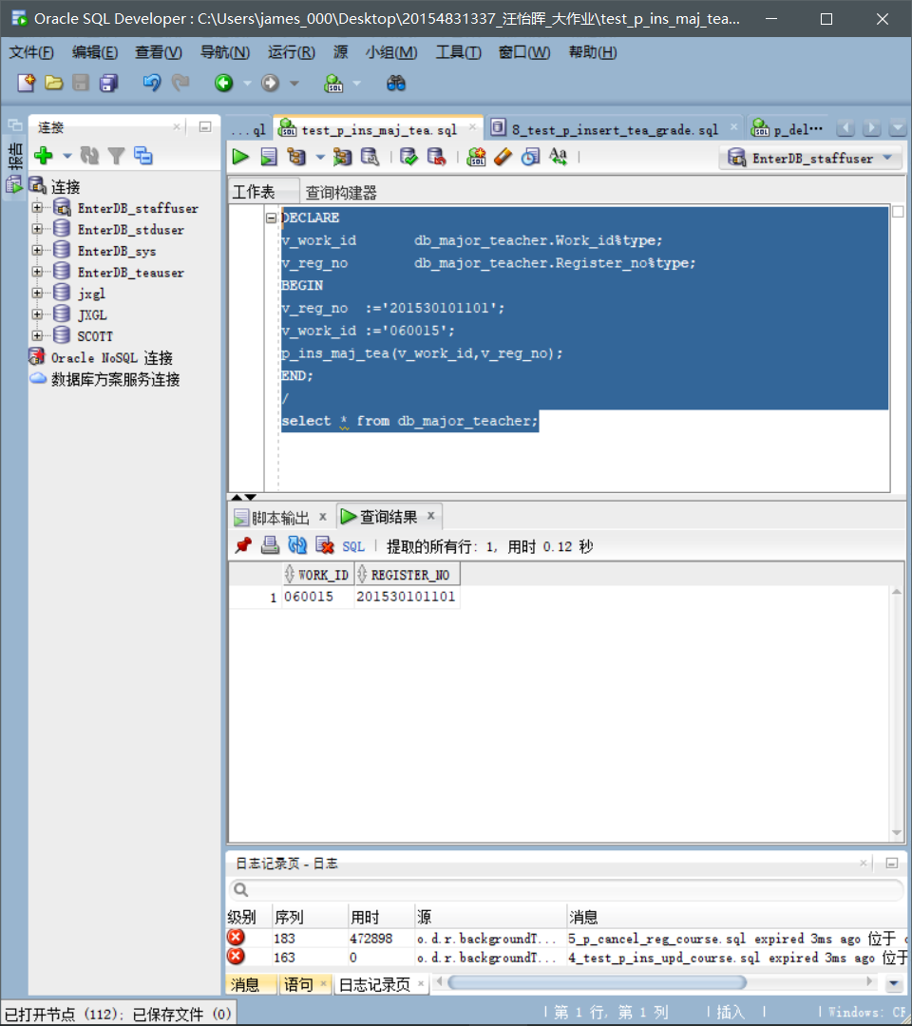

1. **测试脚本：test_** **p_dele_maj_std**

set serveroutput on

DECLARE

v_work_id db_major_teacher.work_id%type default '060015';

v_reg_no db_major_teacher.register_no%type default '201530101101';

BEGIN

p_dele_maj_std(v_work_id,v_reg_no);

END;

/

select * from db_major_teacher;

**测试内容：**

为工号为060015的教师删除学号为201530101101的辅导学生。

**截图：**

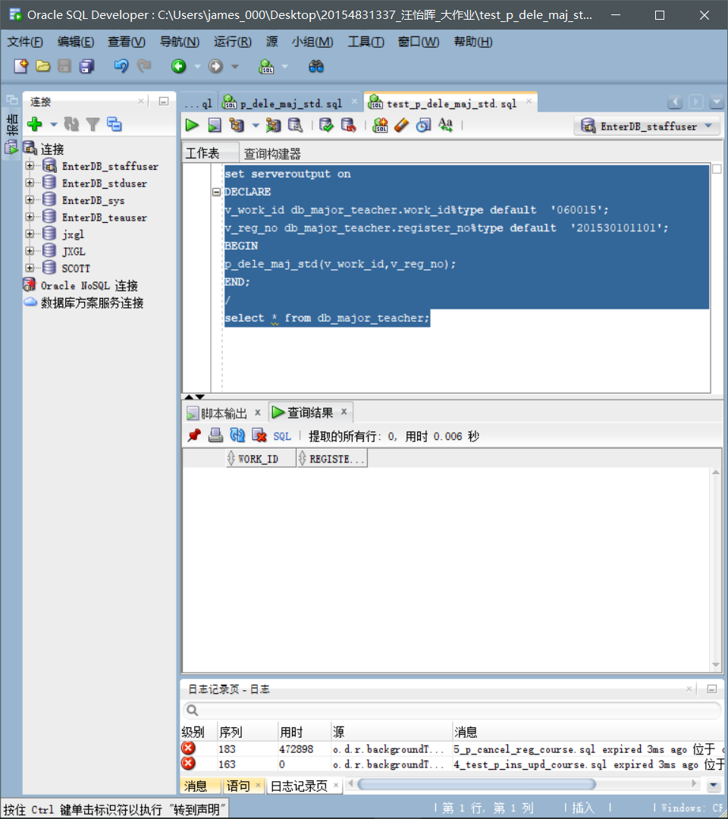

1. **测试脚本：test_** **p_std_tot_gpa**

set serveroutput on

DECLARE

v_reg_no db_grade.register_no%type default '201530101101';

v_gpa number;

BEGIN

p_std_tot_gpa(v_reg_no,v_gpa);

DBMS_OUTPUT.PUT_LINE ('学号：'||v_reg_no);

DBMS_OUTPUT.PUT_LINE ('GPA：'||v_gpa);

END;

/

**测试内容：**

查询学号为201530101101的学生的GPA。

**截图：**

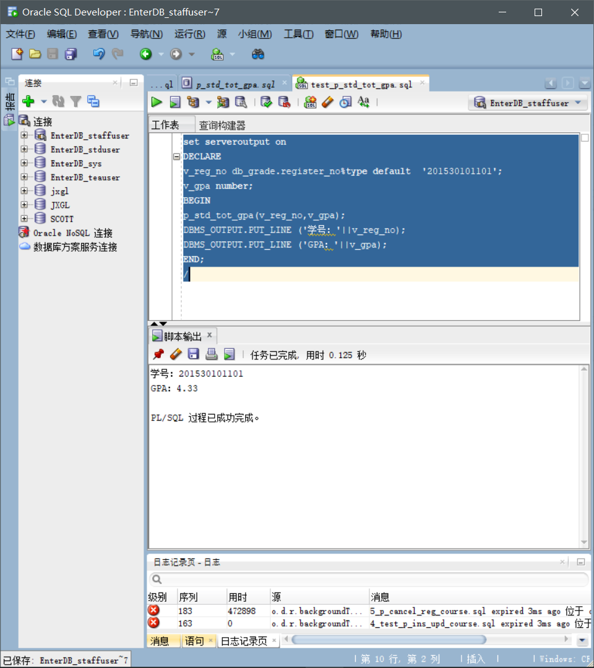

**1. 存储过程**

**测试脚本：1_test_p_query_std_inf.sql**

set serveroutput on

DECLARE

v_reg_no db_student.register_no%type default '201530101101';

v_name db_student.s_name%type;

v_birthday db_student.s_dateofbirth%type;

v_address db_student.s_address%type;

v_postcode db_student.s_postcode%type;

v_mail_address db_student.s_mail_address%type;

v_tele db_student.s_tele%type;

v_email db_student.s_email%type;

BEGIN

p_query_std_inf(v_reg_no,v_name,v_birthday,v_address,v_postcode,v_mail_address,v_tele,v_email);

DBMS_OUTPUT.PUT_LINE ('学号：'||v_reg_no);

DBMS_OUTPUT.PUT_LINE ('姓名：'||v_name);

DBMS_OUTPUT.PUT_LINE ('生日：'||v_birthday);

DBMS_OUTPUT.PUT_LINE('家庭地址:'||v_address);

DBMS_OUTPUT.PUT_LINE('邮编：'||v_postcode);

DBMS_OUTPUT.PUT_LINE('通讯地址：'||v_mail_address);

DBMS_OUTPUT.PUT_LINE('联系电话：'||v_tele);

DBMS_OUTPUT.PUT_LINE('电子信箱：'||v_email);

END;

/

**测试内容：**

查询学号为201530101101的学生的个人信息。

**截图：**

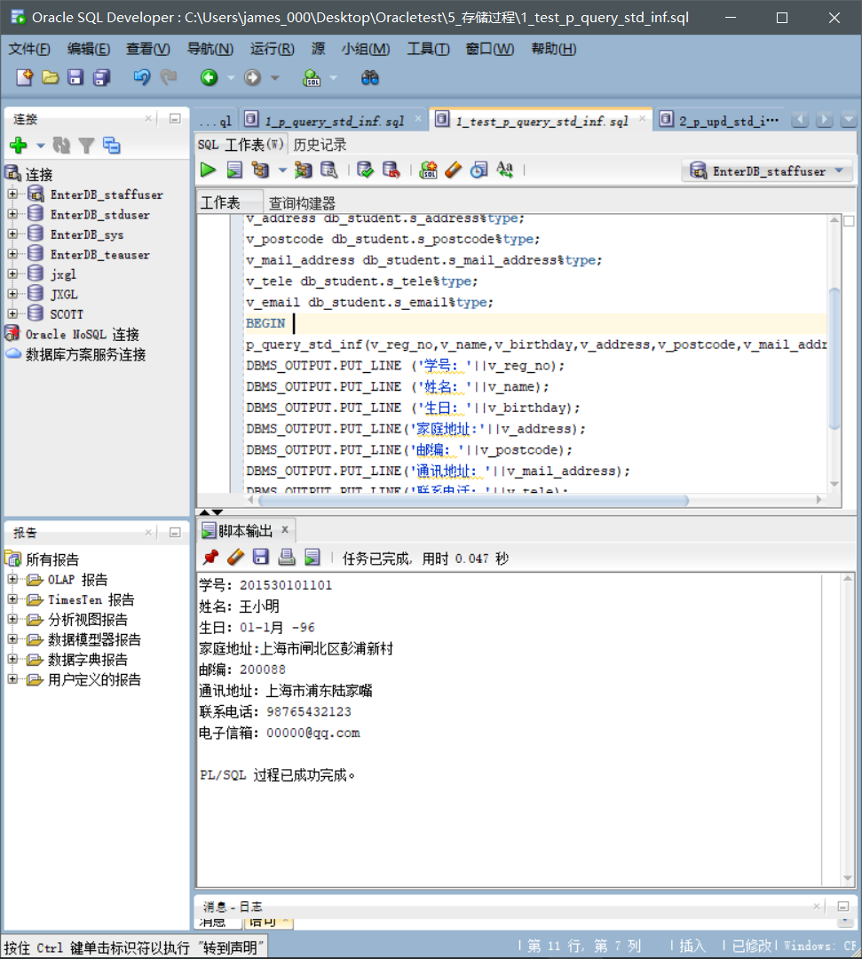

**测试脚本：2_test_p_upd_std_inf.sql**

set serveroutput on

DECLARE

v_reg_no db_student.register_no%type;

v_name db_student.s_name%type;

v_birthday db_student.s_dateofbirth%type;

v_address db_student.s_address%type;

v_postcode db_student.s_postcode%type;

v_mail_address db_student.s_mail_address%type;

v_tele db_student.s_tele%type;

v_email db_student.s_email%type;

BEGIN

v_reg_no:= '201530101101';

v_name:='张大明';

v_birthday:='06-6月-00';

v_address:= '上海市浦东新区曹路镇';

v_postcode:='255588';

v_mail_address:='上海市杨浦区五角场';

v_tele:='00000001111';

v_email:='666@qq.com';

p_upd_std_inf(v_reg_no,v_name,v_birthday,v_address,v_postcode,v_mail_address,v_tele,v_email);

commit;

END;

/

select*from db_student where register_no='201530101101';

**测试内容：**

修改学号为201530101101的学生的个人信息。

**截图：**

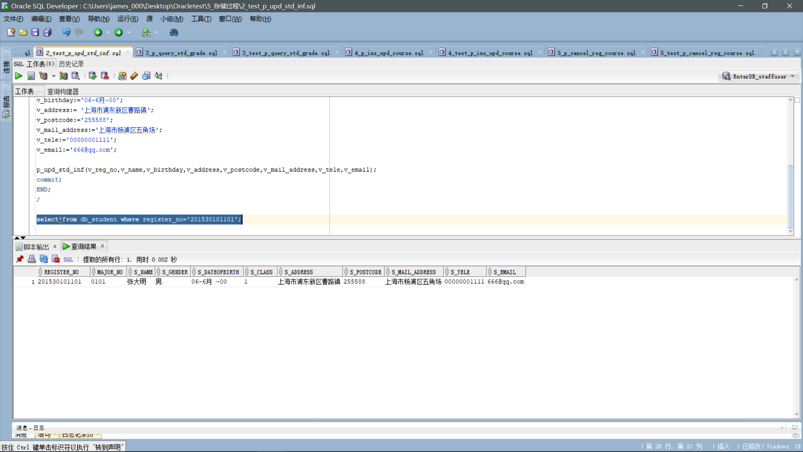

**测试脚本：3_test_p_query_std_grade.sql**

set serveroutput on

DECLARE

v_reg_no db_grade.register_no%type default '201530101101';

v_course_name db_grade.course_name%type default '计算机网络';

v_final_grade db_grade.final_grade%type;

BEGIN

p_query_std_grade(v_reg_no,v_course_name,v_final_grade);

DBMS_OUTPUT.PUT_LINE ('学号：'||v_reg_no);

DBMS_OUTPUT.PUT_LINE('课程名称：'||v_course_name);

DBMS_OUTPUT.PUT_LINE('成绩：'||v_final_grade);

END;

/

**测试内容：**

查询学号为201530101101的学生的“计算机网络”课程的考试成绩。

**截图：**

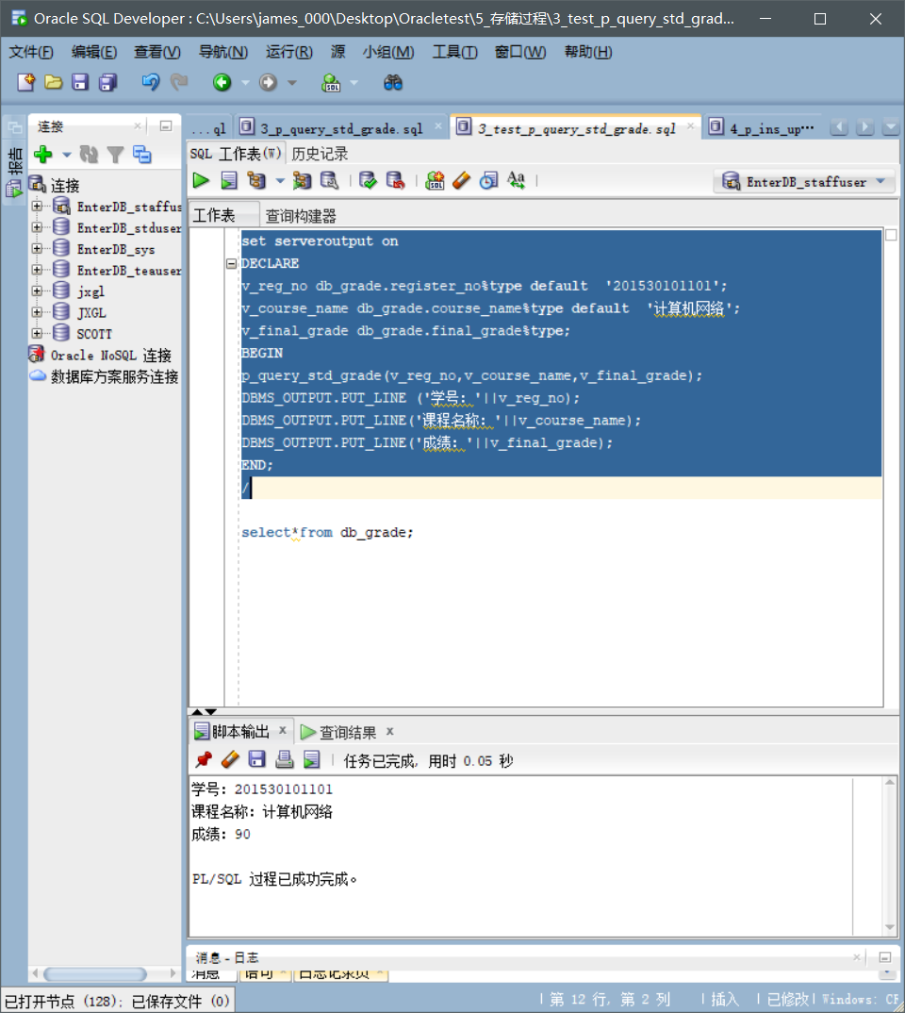

**测试脚本：4_test_p_ins_upd_course.sql**

DECLARE

v_reg_no db_grade.Register_no%type;

v_course_no db_grade.course_no%type;

v_course_name db_grade.course_name%type;

v_work_id db_grade.Work_id%type;

v_college_no db_grade.course_name%type;

v_reg_date db_grade.Registered_date%type;

v_reg_year db_grade.Registered_year%type;

v_reg_term db_grade.Registered_term%type;

v_credit db_grade.credit%type;

BEGIN

v_reg_no :='201530101102';

v_course_no:='CS270';

v_course_name :='数据结构';

v_work_id :='070001';

v_college_no:='04';

v_reg_date := sysdate;

v_reg_year :='2017-2018';

v_reg_term :='1';

v_credit :=2.5;

p_ins_upd_course(v_reg_no,v_course_no,v_course_name,v_work_id,

v_college_no,v_reg_date,v_reg_year,v_reg_term,v_credit);

END;

/

select*from db_grade;

**测试内容：**

为学号为201530101102的学生选择课程编号为“CS270”、课程名称为“数据结构”、任课教师工作号为“070001”的课程。

**截图：**

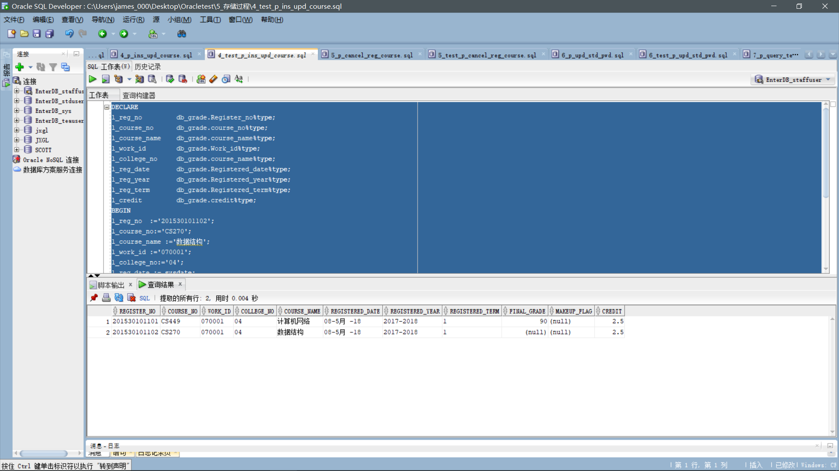

**测试脚本：5_test_p_cancel_reg_course.sql**

set serveroutput on

DECLARE

v_reg_no db_grade.register_no%type default '201530101102';

v_course_no db_grade.course_no%type default 'CS270';

v_work_id db_grade.work_id%type default '070001';

BEGIN

p_cancel_reg_course(v_reg_no,v_course_no,v_work_id);

END;

/

select * from DB_GRADE;

**测试内容：**

将学号为201530101102的学生的课程编号为“CS270”、任课教师工作号为“070001”的课程取消。

**截图：**

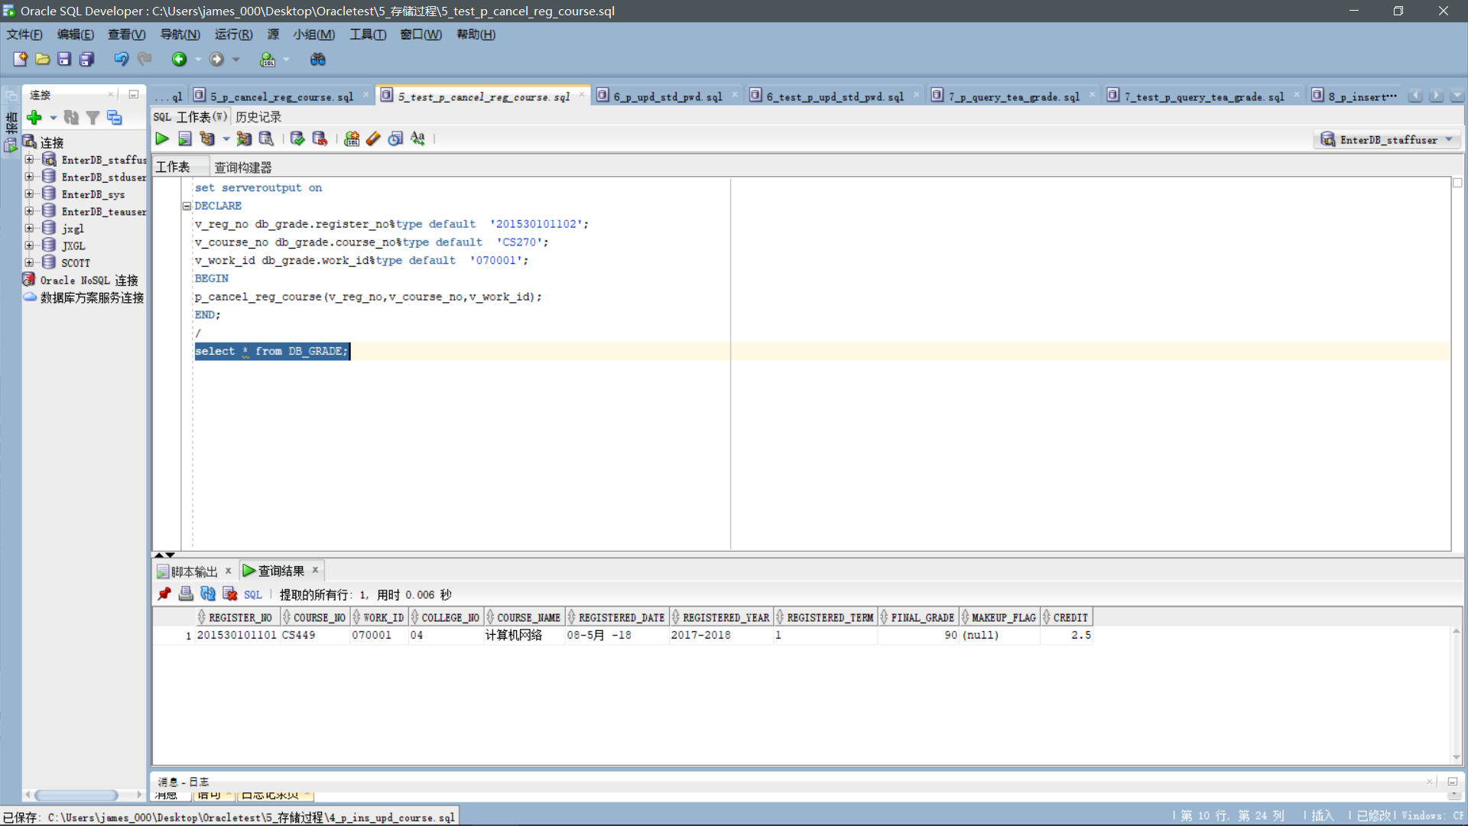

**测试脚本：6_test_p_upd_std_pwd.sql**

set serveroutput on

DECLARE

v_reg_no DB_STUDENT_PER.register_no%type;

v_password DB_STUDENT_PER.LOGIN_PWD_S%type;

v_password_new DB_STUDENT_PER.LOGIN_PWD_S%type;

BEGIN

v_reg_no:= '201530101101';

v_password:='123456';

v_password_new:='666666';

p_upd_std_pwd(v_reg_no,v_password,v_password_new);

commit;

END;

/

select * from DB_STUDENT_PER;

**测试内容：**

将学号为201530101101的学生的密码修改为666666。

**截图：**

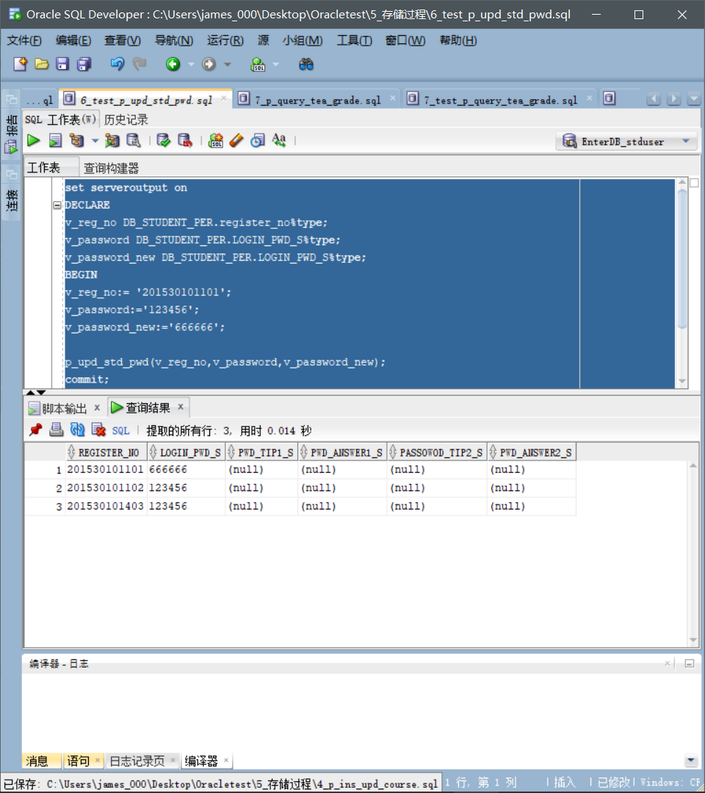

**测试脚本：7_test_p_query_tea_grade.sql**

set serveroutput on

DECLARE

v_reg_no db_grade.register_no%type default '201530101101';

v_work_id db_grade.work_id%type default '070001';

v_course_name db_grade.course_name%type default '计算机网络';

v_final_grade db_grade.final_grade%type;

BEGIN

p_query_tea_grade(v_reg_no,v_work_id,v_course_name,v_final_grade);

DBMS_OUTPUT.PUT_LINE ('学号：'||v_reg_no);

DBMS_OUTPUT.PUT_LINE('教师工号：'||v_work_id);

DBMS_OUTPUT.PUT_LINE('课程名称：'||v_course_name);

DBMS_OUTPUT.PUT_LINE('成绩：'||v_final_grade);

END;

/

**测试内容：**

查询学号为201530101101的学生的课程名称为“计算机网络”、任课教师工号为“070001”的课程的考试成绩。

**截图：**

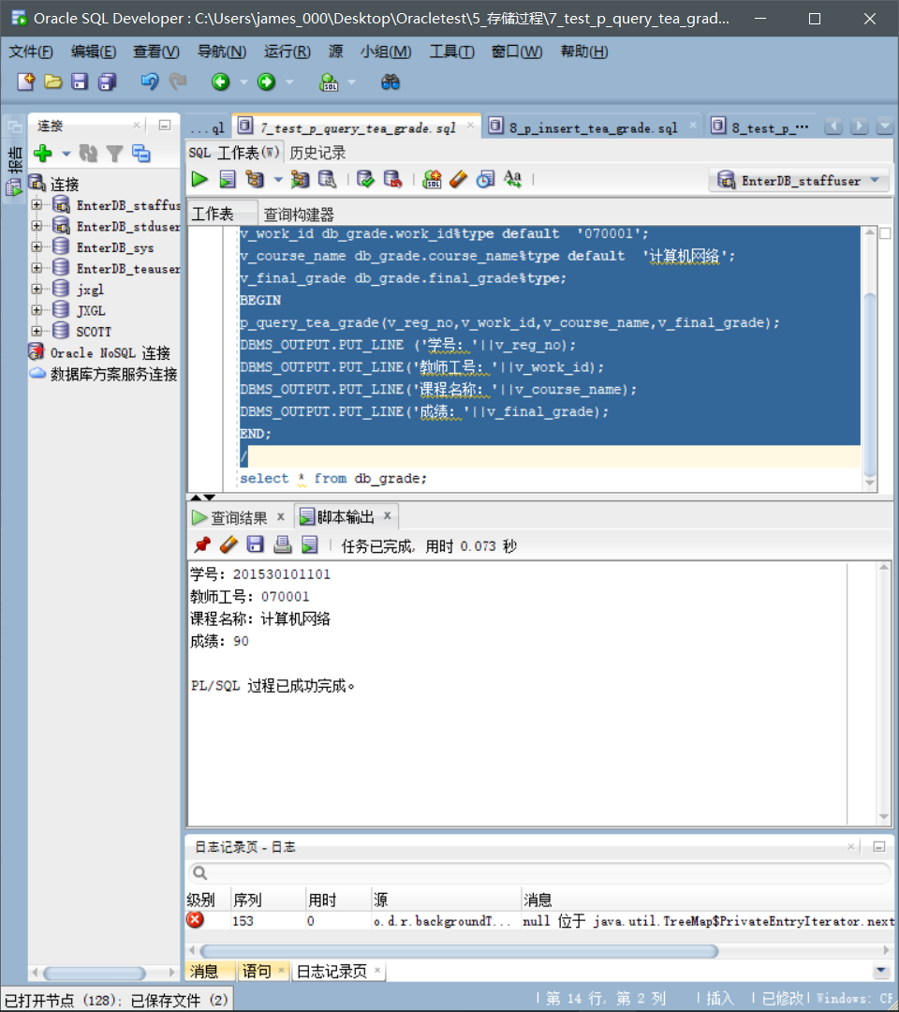

**测试脚本：8_test_p_insert_tea_grade.sql**

DECLARE

v_reg_no db_grade.Register_no%type;

v_course_no db_grade.course_no%type;

v_course_name db_grade.course_name%type;

v_work_id db_grade.Work_id%type;

v_college_no db_grade.course_name%type;

v_reg_date db_grade.Registered_date%type;

v_reg_year db_grade.Registered_year%type;

v_reg_term db_grade.Registered_term%type;

v_final_grade db_grade.final_grade%type;

v_credit db_grade.credit%type;

BEGIN

v_reg_no :='201530101101';

v_course_no:='CS328';

v_course_name :='计算机组成原理';

v_work_id :='060015';

v_college_no:='04';

v_reg_date := sysdate;

v_reg_year :='2017-2018';

v_reg_term :='1';

v_final_grade:='98';

v_credit :=2.5;

p_insert_tea_grade(v_reg_no,v_course_no,v_course_name,v_work_id,

v_college_no,v_reg_date,v_reg_year,v_reg_term,v_final_grade,v_credit);

END;

/

select * from DB_GRADE;

**测试内容：**

将学号为201530101101的学生的课程编号为“CS328”、课程名称为“计算机组成原理”、任课教师工号为“060015”的课程的考试成绩录入为98分。

**截图：**

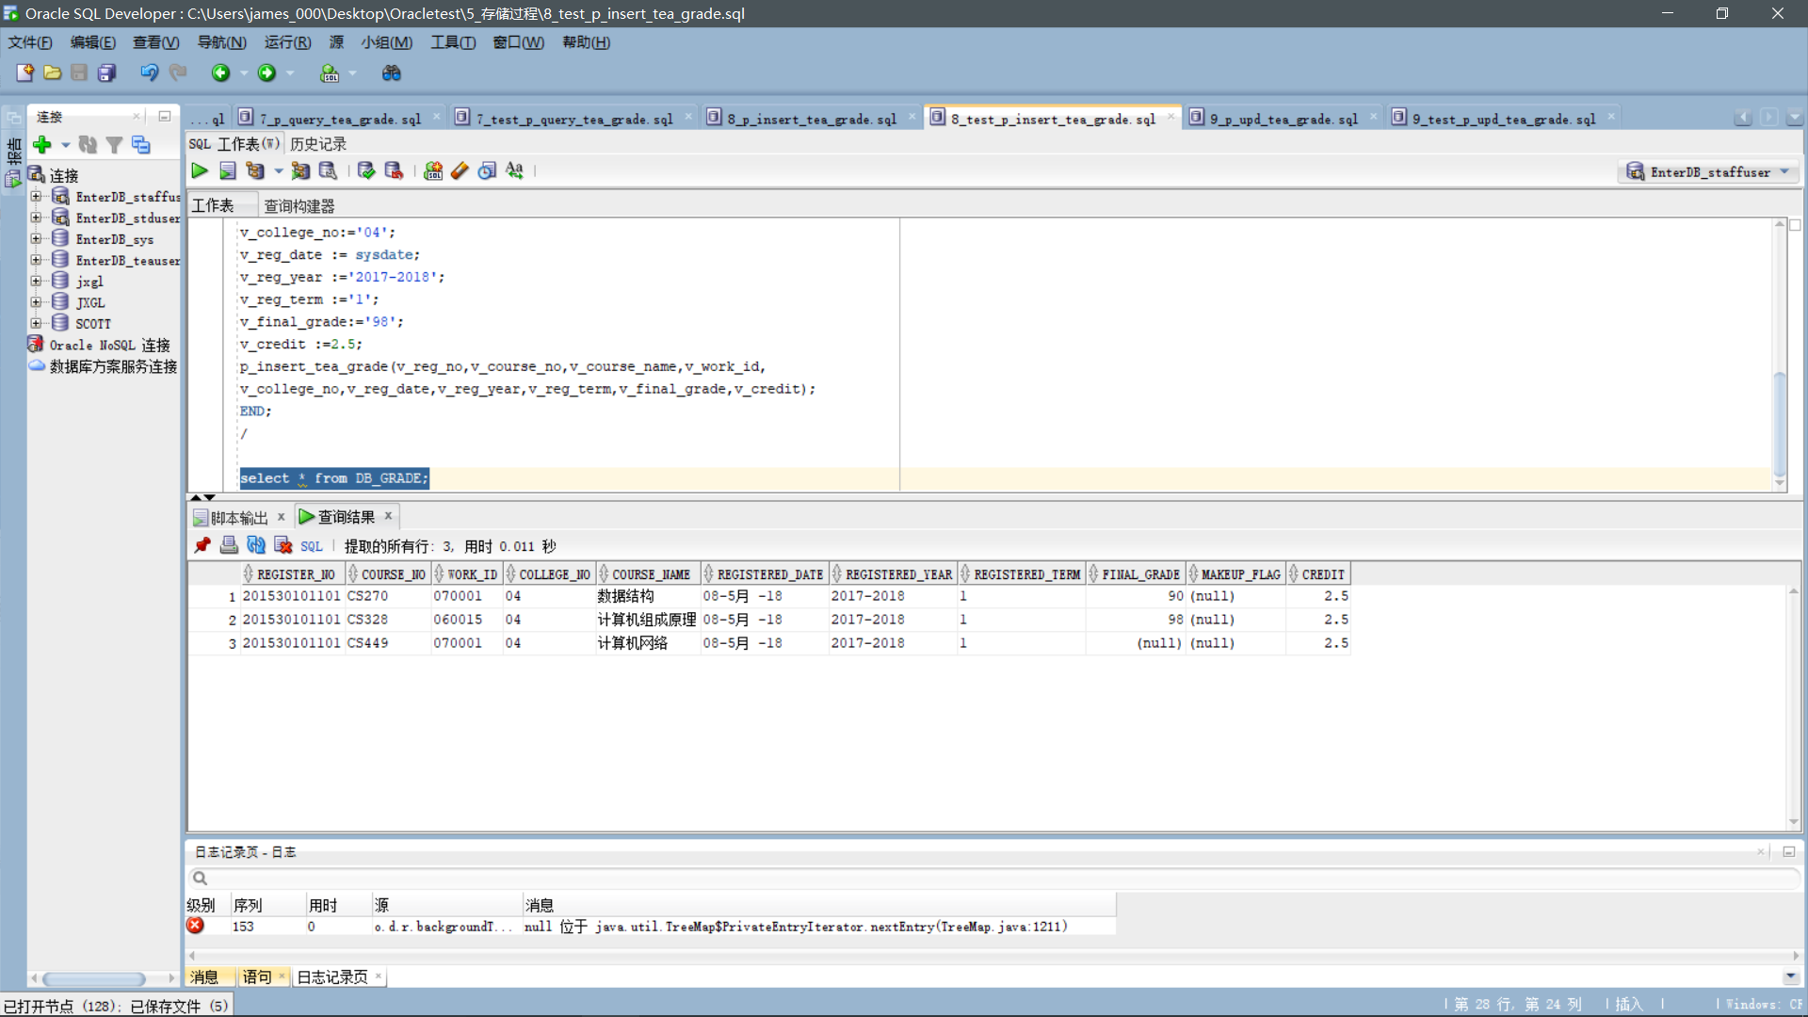

**测试脚本：9_test_p_upd_tea_grade.sql**

DECLARE

l_reg_no db_grade.Register_no%type;

l_course_no db_grade.course_no%type;

l_course_name db_grade.course_name%type;

l_work_id db_grade.Work_id%type;

l_college_no db_grade.course_name%type;

l_reg_year db_grade.Registered_year%type;

l_reg_term db_grade.Registered_term%type;

l_final_grade db_grade.final_grade%type;

l_credit db_grade.credit%type;

BEGIN

l_reg_no :='201530101101';

l_course_no:='CS449';

l_course_name :='计算机网络';

l_work_id :='070001';

l_college_no:='04';

l_reg_year :='2017-2018';

l_reg_term :='1';

l_final_grade:='92';

l_credit :=2.5;

p_upd_tea_grade(l_reg_no,l_course_no,l_course_name,l_work_id,

l_college_no,l_reg_year,l_reg_term,l_final_grade,l_credit);

END;

/

select * from DB_GRADE;

**测试内容：**

将学号为201530101101的学生的课程编号为“CS449”、课程名称为“计算机网络”、任课教师工号为“070001”的课程的考试成绩修改为92分。

**截图：**

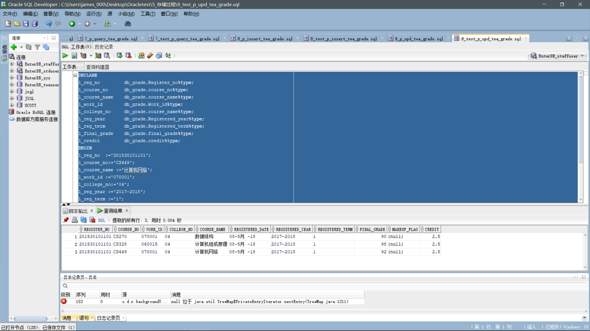

**测试脚本：10_test_p_upd_tea_pwd.sql**

set serveroutput on

DECLARE

v_work_id db_faculty_per.work_id%type;

v_password db_faculty_per.LOGIN_PWD_F%type;

v_password_new db_faculty_per.LOGIN_PWD_F%type;

BEGIN

v_work_id:= '020013';

v_password:='123456';

v_password_new:='666666';

p_upd_tea_pwd(v_work_id,v_password,v_password_new);

commit;

END;

/

select * from db_faculty_per;

**测试内容：**

将工号为020013的老师的密码修改为666666。

**截图：**

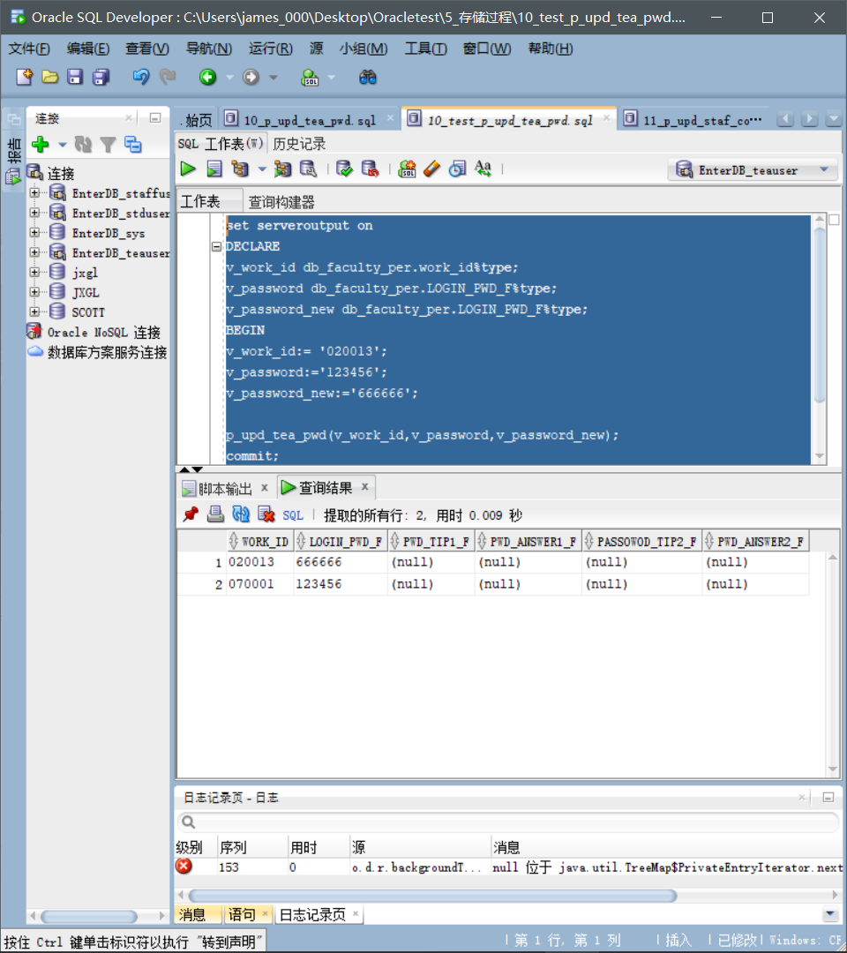

**测试脚本：11_test_p_upd_staf_course.sql**

set serveroutput on

DECLARE

v_work_id db_teach_course.work_id%type;

v_course_no db_teach_course.course_no%type;

v_course_no_new db_teach_course.course_no%type;

v_course_name db_teach_course.course_name%type;

BEGIN

v_work_id:= '050011';

v_course_no:= 'PHY638';

v_course_no_new:='CS243';

v_course_name:='编译原理';

p_upd_staf_course(v_work_id,v_course_no,v_course_no_new,v_course_name);

commit;

END;

/

select * from db_teach_course;

**测试内容：**

将工号为050011的老师的教学计划修改为课程编号为“CS243”、课程名称为“编译原理”的课程。

**截图：**

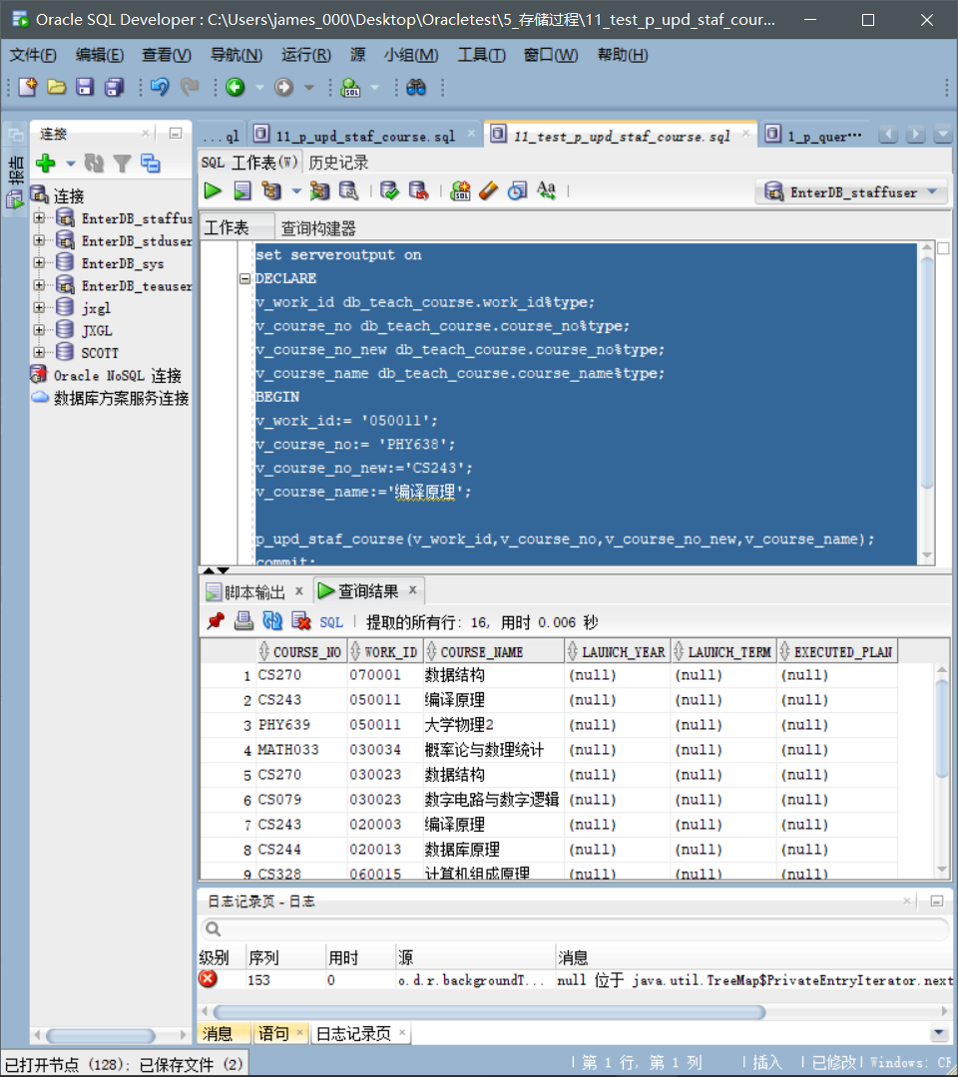

**2. 函数**

**1_fun_query_std_gra.sql**

set serveroutput on

begin

DBMS_OUTPUT.PUT_LINE (fun_query_std_gra('201530101101','CS449','070001'));

end;

**测试内容：**

查询学号为201530101101的学生的课程编号为“CS449”、教师工号为“070001”的课程的单科考试成绩。

**截图：**

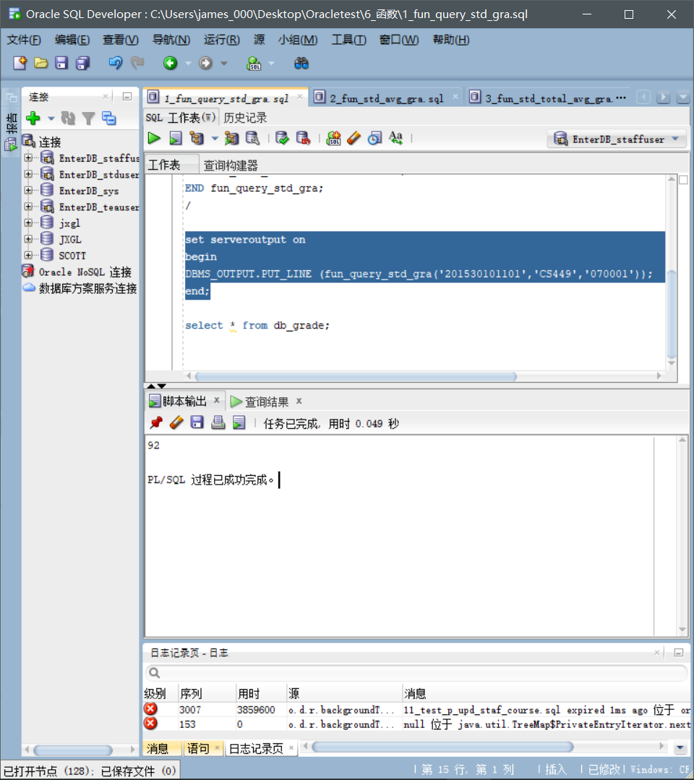

**2_fun_std_avg_gra.sql**

set serveroutput on

begin

DBMS_OUTPUT.PUT_LINE (round(fun_std_avg_gra('201530101101','1'),2));

end;

**测试内容：**

查询学号为201530101101的学生第一学期的考试平均成绩。

**截图：**

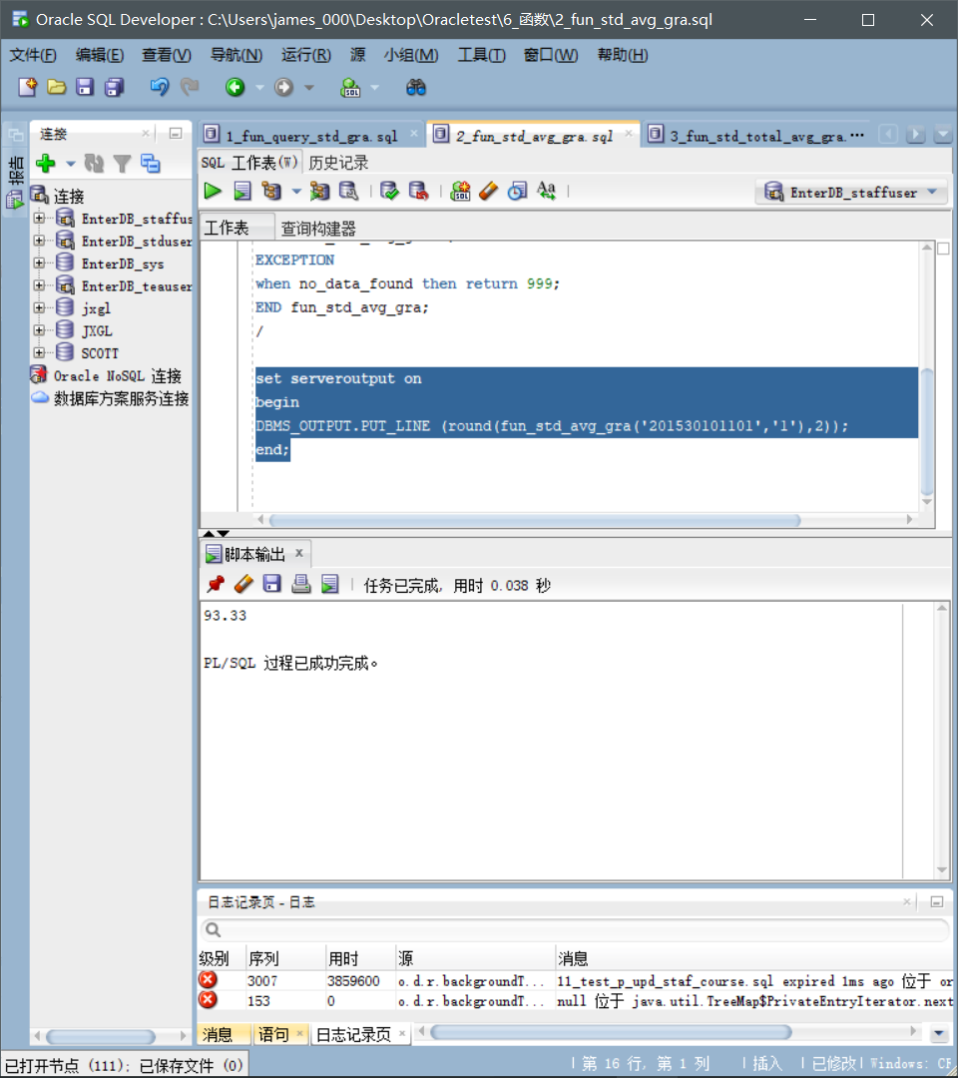

**3_fun_std_total_avg_gra.sql**

set serveroutput on

begin

DBMS_OUTPUT.PUT_LINE (round(fun_std_total_avg_gra('201530101101'),2));

end;

**测试内容：**

查询学号为201530101101的学生的所有考试平均成绩。

**截图：**

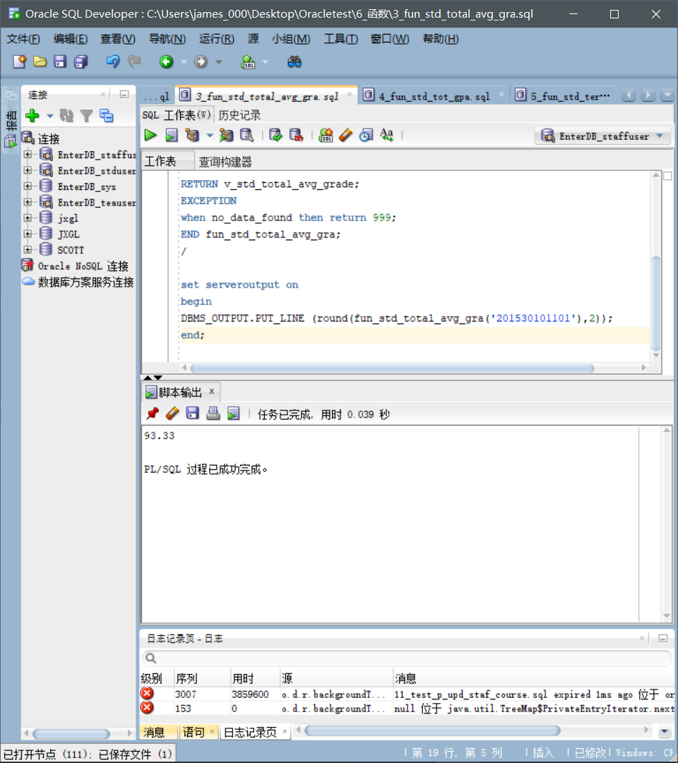

**4_fun_std_tot_gpa.sql**

set serveroutput on

begin

DBMS_OUTPUT.PUT_LINE (round(fun_std_tot_gpa('201530101101'),2));

end;

**测试内容：**

查询学号为201530101101的学生的GPA。

**截图：**

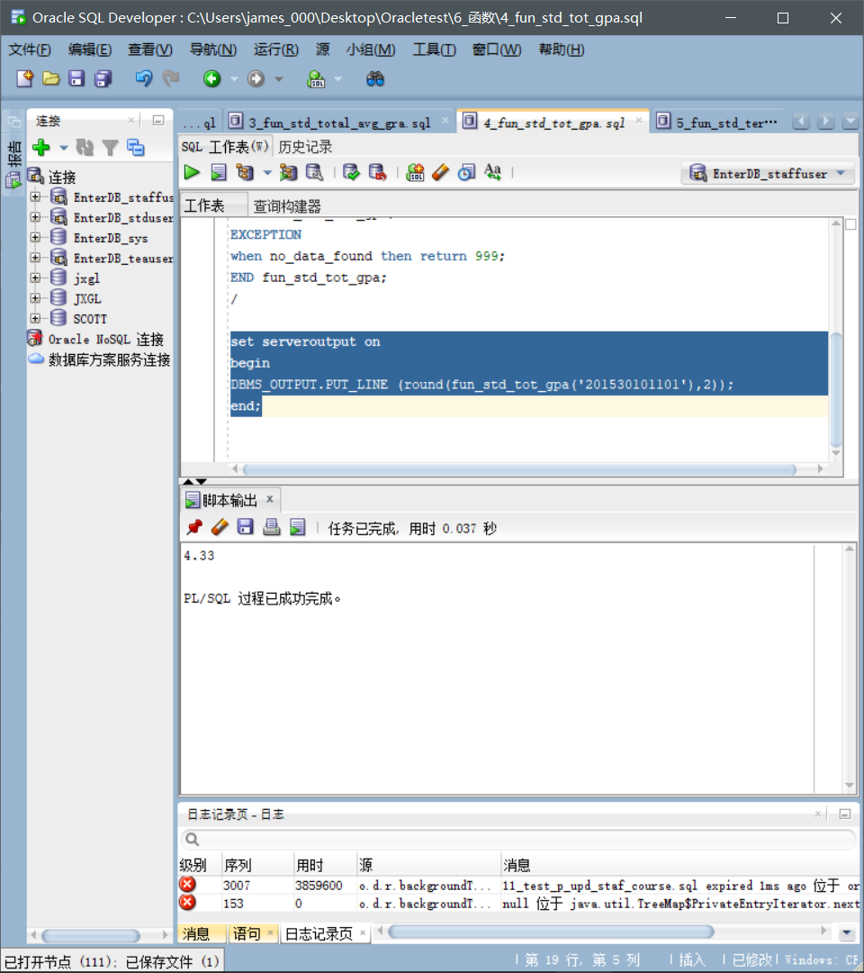

**5_fun_std_term_avg_gra.sql**

set serveroutput on

begin

DBMS_OUTPUT.PUT_LINE (round(fun_std_term_avg_gra('0303','1'),2));

end;

**测试内容：**

查询专业编号为“0303”的专业的第一学期学生平均成绩。

**截图：**

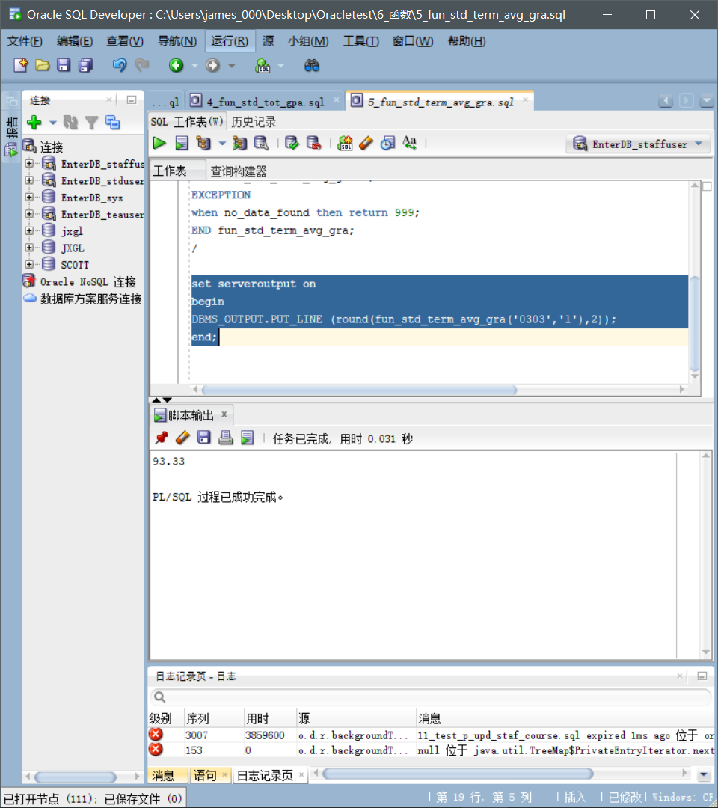

**3. 触发器**

**1_tri_startup_db.sql&2_tri_shutdown_db.sql**

Select * from updown_log;

**测试内容：**

记录数据库启动、关闭的时间及用户。

**截图：**

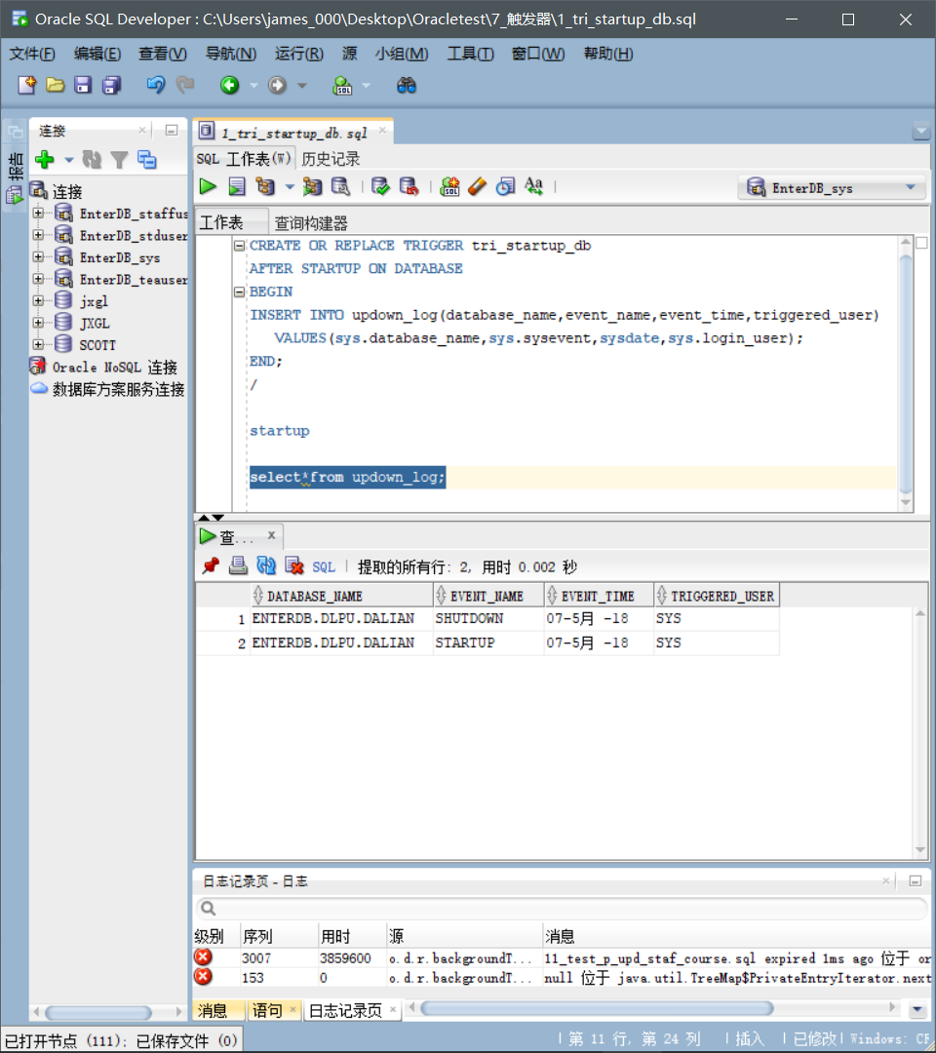

**3_tri_login_user.sql&4_tri_logout_user.sql**

Select * from user_login_log;

**测试内容：**

自动记录登录、注销系统的用户信息，包括IP、主机名、登录时间、用户名等。

**截图：**

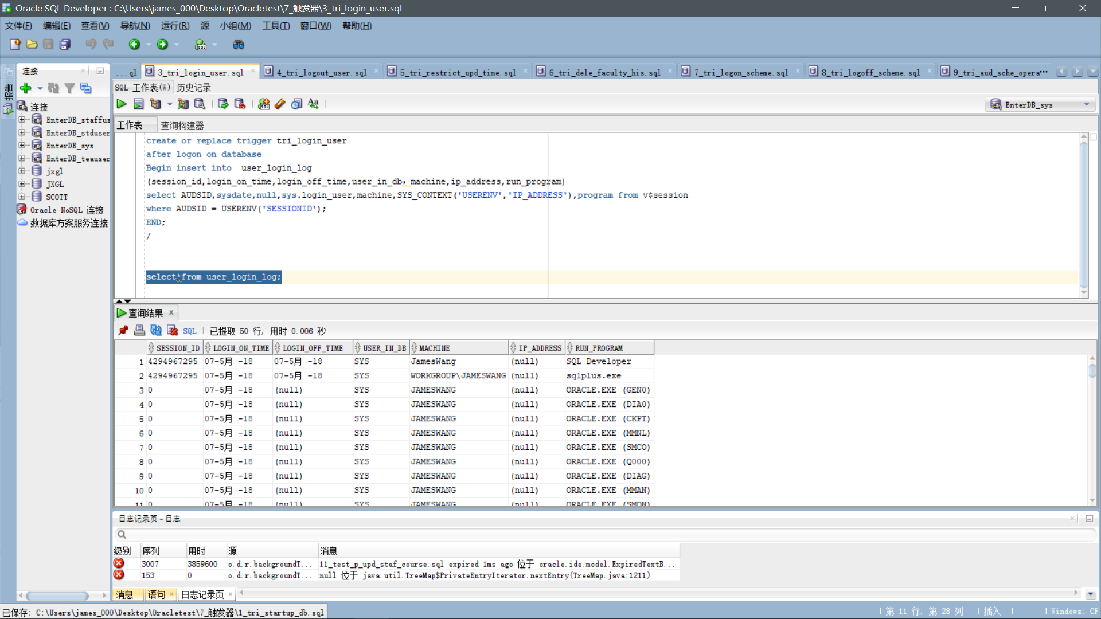

**5_tri_restrict_upd_time.sql**

**测试内容：**

将系统时间设置为星期日中午12：01，测试在周六、周日上午8点至下午5点不能对数据库db_grade表进行更新修改。

**截图：**

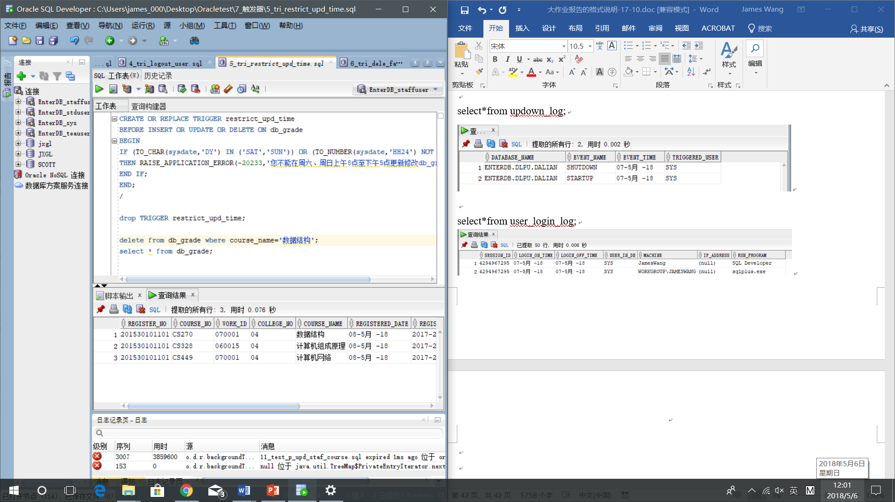

delete from db_grade where course_name='数据结构';

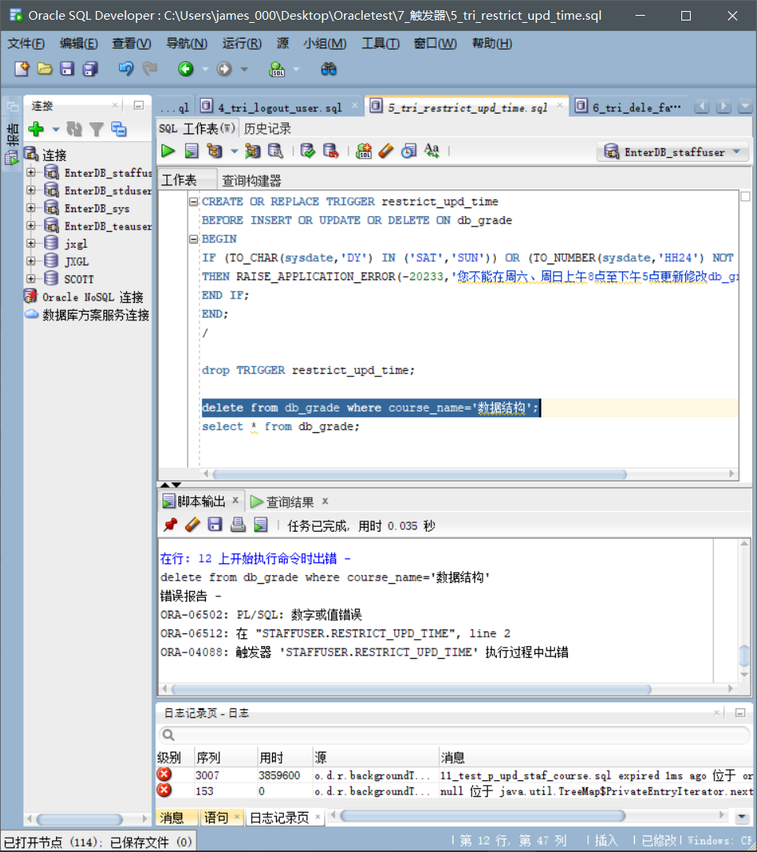

**6_tri_dele_faculty_his.sql**

Select * from db_dele_faculty;

**测试内容：**

删除姓名为“石方法”的教师，自动记录离职教师的信息。

**截图：**

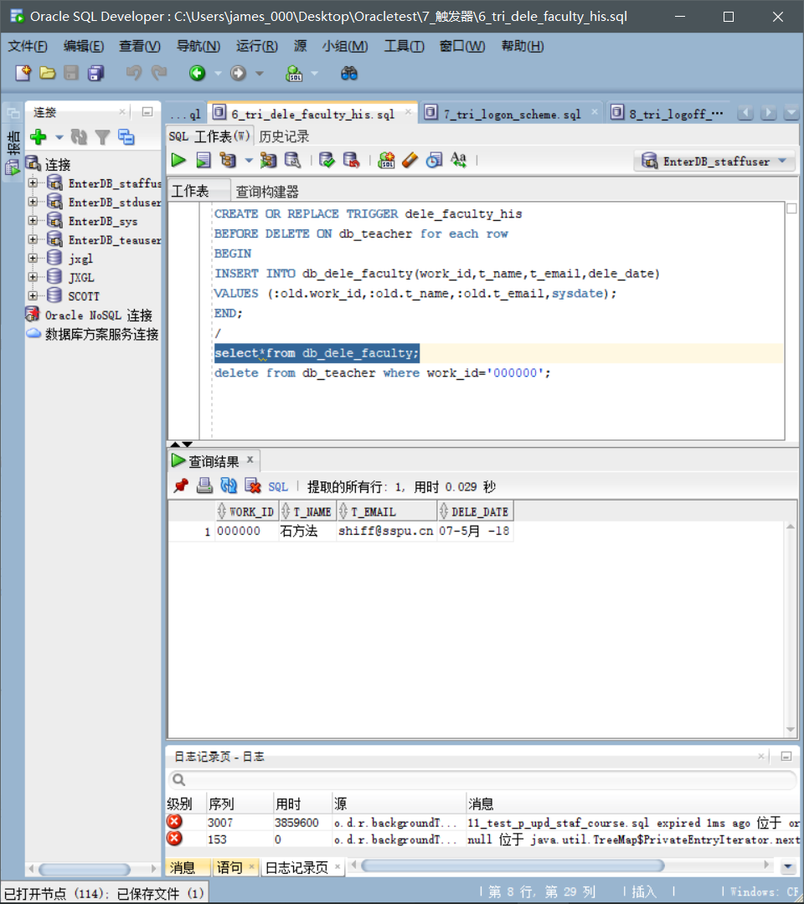

**7_tri_logon_scheme.sql&8_tri_logoff_scheme.sql**

SELECT * FROM db_log_event;

**测试内容：**

登录、注销用户时系统自动记录用户信息。

**截图：**

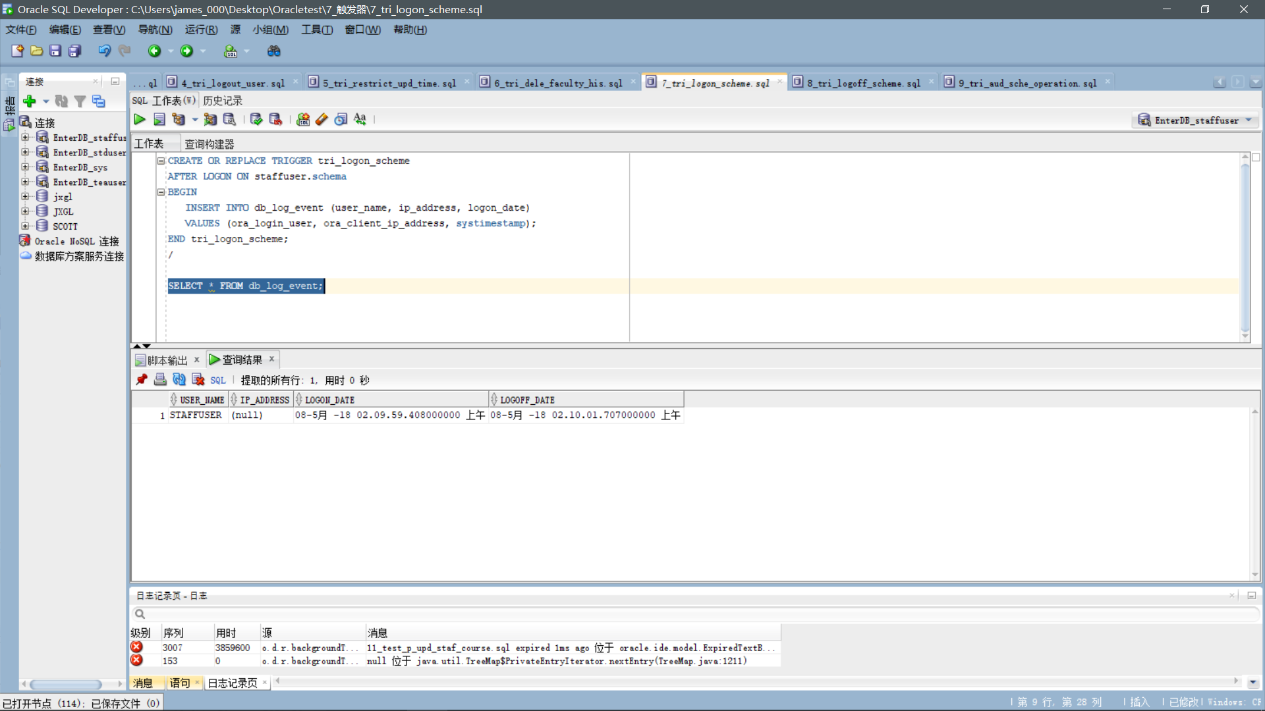

**9_tri_aud_sche_operation.sql**

Select * from db_scheme_activities;

**测试内容：**

自动记录用户的DLL操作。

**截图：**

